

Research Officer’s Annual Report

Baby Giant tortoise Dipsochelys dussumeiri from Picard weighing about 50 gr and measuring 8 cm.
Photo by B. Bautil

January – December 2005
Compiled by Bruno Bautil

1. Introduction……………………………………………………………………….6

2. Turtles………………………………………………………………………….…7-12
2.1 Turtle tagging……………………………………………………………….7-10
2.1.1 Nesting turtles…………………………………………………………7-8
2.1.2 Juvenile green turtles………………………………………………….8
2.1.3 Inaccuracy of morphometric measurements………………………..9-10
2.2 Track counts………………………………………………………………..10-12

3. Tortoises………………………………………………………………………….13-25
3.1 Introduction…………………………………………………………………13-14
3.2 Model results –threat analysis and annual trends per transect…………15-21
3.2.1 Grande Terre…………………………………………………………15-16
3.2.1.1 Groves transect…………………………………………………15
3.2.1.2 Coco transect…………………………………………………....15-16
3.2.1.3 Coastal transect…………………………………………………16
3.2.1.4 Dune D’Messe coastal…………………………………………..16-17
3.2.1.5 Dune D’Messe Inland…………………………………………...17
3.2.1.6 Dune Jean-Louis………………………………………………...18
3.2.2 Malabar Island………………………………………………………...18-19
3.2.2.1 Malabar transect………………………………………………..18
3.2.2.2 Middle Camp Inland……………………………………………19
3.2.2.3 Middle Camp Casuarina………………………………………..19
3.2.3 Picard Island…………………………………………………………..20-21
3.2.3.1 Coastal…………………………………………………………...20
3.2.3.2 Back Path………………………………………………………..20
3.2.3.3 Anse Var…………………………………………………………21
3.3 Discussion and further analysis……………………………………………21-25
3.3.1 Trends in numbers per island with future predictions…………….21-24
3.3.1.1 Grande Terre…………………………………………………...21-22
3.3.1.2 Picard Island……………………………………………………22-23
3.3.1.3 Malabar Island…………………………………………………23-24
3.3.2 Mean scute size………………………………………………………24-25
3.3.3 Sex ratios……………………………………………………………...25

4. Birds………………………………………………………………………………26-30
4.1 Land birds…………………………………………………………………..26
4.2 Rail monitoring……………………………………………………………..27
4.3 Wader counts……………………………………………………………….27-28
4.4 Rare bird sightings…………………………………………………………28-30

5. Climate…………………………………………………………………………...31-33

List of Tables and figures

Table 1.1: The number of turtles handled in 2004……………………………………………………7

Table 2.1: The number of recaptured turtles tagged prior to 2004………………………………….7

Table 2.1: Tortoise: Threat analysis –Cinq Cases Groves……………………..……………………15

Table 2.2: Threat analysis –Cinq Cases Coco………………………………………………………..16

Table 2.3: Threat analysis –Cinq Cases Coastal……………………………………………………..16

Table 2.4: Threat analysis –DDM coastal……………………………………………………………17

Table 2.5: Threat analysis –DDM Inland…………………………………………………………….17

Table 2.6: Threat analysis –DJL……………………………………………………………………...18

Table 2.7: Threat analysis –Malabar transect……………………………………………………….18

Table 2.8: Threat analysis –Middle Camp Inland…………………………………………………..19

Table 2.9: Threat analysis –Middle Camp Casuarina………………………………………………19

Table 2.10: Threat analysis –Picard Coastal………………………………………………………...20

Table 2.11: Threat analysis –Picard Back Path……………………………………………………..20

Table 2.12: Threat analysis –Picard Anse Var………………………………………………………21

Table 2.13: Total number of tortoises counted on each of the three Islands on Aldabra since 1996………………………………………………………………………………….22

Table 2.14: Length of 3_{rd} scute of tortoise from each transect between 1996 and 2005…………...30

Table 3.1: The number of land birds counted per annum………………………………………….26

Table 3.2: The number of rails counted per transect in 2004……………………………………...27

Table 3.3: Number of waders counted along the settlement transect in 2004…………………….27

Table 3.4: Number of waders counted between Dune Jean-Louis and Dune D’Messe in 2004….28

Table 3.5: Opportunistic sightings of Little tern in 2004……………………………………………28

Table 3.6: Opportunistic sightings of Broad-billed roller in 2004………………………………….28

Table 3.7: Opportunistic sightings of Brown booby in 2004………………………………………..28

Table 3.8: Opportunistic sightings of Curlew sandpiper in 2004…………………………………...28

Table 3.9: Opportunistic sightings of Greater Flamingo in 2004…………………………………..29

Table 3.10: Opportunistic sightings of Caspian tern in 2004……………………………………….29

Table 3.11: Opportunistic sightings of Greater sandplover in 2004………………………………..29

Table 3.12: Opportunistic sightings of Lesser sandplover in 2004…………………………………29

Table 3.13: Opportunistic sightings of Greenshank in 2004……………………………………….30

Table 3.14: Opportunistic sightings of Eurasian golden oriole in 2004…………………………...30

Table 3.15: Opportunistic sightings of Tree pipit in 2004………………………………………….30

Table 3.16: Opportunistic sightings of Sanderlings in 2004………………………………………...30

Table 4.1: Outstation rain gauge readings. Figures in red are those where it is uncertain
which calibration was used. During January to June, no research officer was
present……………………………………………………………………………………..31

Figure 1.1: The number of nesting green turtles tagged at various beaches in 2004……………….7

Figure 1.2: The number of turtles encountered and the corresponding percentage of
untagged individuals over the years……………………………………………………..8

Figure 1.3: The number of juvenile turtles captured at the various rodeo locations and the
corresponding percentage of untagged individuals over the years…………………….8

Figure 1.4: Mean inaccuracy indices for nesting green turtle carapace measurements in 2003
and 2004 (OCCL = ’Over the curve’)…………………………………………………….9

Figure 1.5: Mean inaccuracy indices for juvenile green turtle morphometric measurements
for 2003 and 2004 (OCCL = ‘Over the curve length’, SLCL = ‘straight line
length’)……………………………………………………………………………………..10

Figure 1.6: Carapace measurements of nesting and juvenile green turtles (nesting turtles only
OCCL, juvenile turtles OCCL + SLCL)…………………………………………………10

Figure 1.7: The number of track counts conducted per beach. 1-22, West Grande Terre;
23-27, Dune D’Messe region; 28-36, Dune Jean Louis region; 37-39,
Cinq Cases region; 40, Anse Cedres; 41-43.5, Anse Malabar region; 44-46,
Gionnet region; 47, settlement beach……………………………………………………11

Figure 1.8: mean number of VF tracks per beach 2000 - 2004

Figure 1.9: Monthly mean numbers of VF tracks on the settlement beach between 1998 and
May 2005 showing 95% confidence intervals. Red columns represent the months
of March and April……………………………………………………………………….12

Figure 1.10: Monthly mean numbers of VF tracks along West Grande Terre beaches
between 2000 and 2004 showing 95% confidence intervals. Red columns
represent the months of March and April…………………………………………….12

Figure 2.1: The location and relative length of tortoise transects around the atoll
(from Bourne 2004)……………………………………………………………………….14

Figure 2.2: Annual trend in numbers –Cinq Cases Groves…………………………………………15
Figure 2.3: Annual trend in numbers –Cinq Cases Coco……………………………………………16

Figure 2.4: Annual trend in numbers –Cinq Cases Coastal…………………………………………16
Figure 2.5: Annual trend in numbers –DDM Coastal……………………………………………….17

Figure 2.6: Annual trend in numbers –DDM Inland………………………………………………...17

Figure 2.7: Annual trend in numbers –DJL………………………………………………………….18

Figure 2.8: Annual trend in numbers -Malabar transect…………………………………………...18

Figure 2.9: Annual trend in numbers –Middle Camp Inland………………………………………19

Figure 2.10: Annual trend in numbers –Middle Camp casuarina………………………………..19

Figure 2.11: Annual trend in numbers –Picard Coastal…………………………………………..20

Figure 2.12: Annual trend in numbers –Picard Back path………………………………………..20

Figure 2.13: Annual trend in numbers –Picard Anse Var………………………………………...21

Figure 2.14: Total number of tortoises counted on Grande Terre per annum. Linear trend
line is insignificant……………………………………………………………………..22

Figure 2.15: Mean annual rainfall at Aldabra. Years 1996 – 1998 omitted due to
incomplete records……………………………………………………………………..22

Figure 2.16: Total number of tortoises counted on Picard and Malabar per annum……………23

Figure 2.17: Total number of tortoises counted on Picard Island per annum. Exponential
trend line is significant………………………………………………………………..23

Figure 2.18: Total number of tortoises counted on Malabar Island per annum. Exponential
trend line is insignificant………………………………………………………………24

Figure 2.19: Mean scute size per transect (derived from pooled data 1996-2004)………………..24

Figure2.20: Mean annual scute length for Dune D’Messe inland and Dune Jean-Louis
Transects (derived from pooled data 1996-2004. Polynomial trend lines are
Significant………………………………………………………………………………..25

Figure 2.21: Sex ratios on the various transects during 2004………………………………………25

Figure 3.1: Total number of land birds counted per annum……………………………………….26

Figure 4.1 Mean dry bulb temperature between 2000 and 2004…………………………………..32

Figure 4.2 Rainfall at the station between 2000 and 2004………………………………………….32

Figure 4.3 Mean precipitation at the various outstations (1999-2004)…………………………….33

Figure 4.4 Mean annual precipitation at Aldabra (1999-2004)…………………………………….34

1. Introduction

On the front page the photo of a baby giant tortoise from Picard was chosen to symbolize the future for the largest population of giant tortoises in the world found on Aldabra.

In 2005, several research officers were in function at Aldabra. From June 2005 to November 2005, Mr Rainer Von Brandis was in charge of research. The present research officer took over the function in November and covered the two last months of 2005.

This annual report is limited to the research and monitoring activities carried out during 2005
There is no chapter regarding the eradication of goats, cats and rats as there is nothing report for 2004 except that 5 goats were shot (after which there were no more bullets). There are also no chapters describing marine or vegetation monitoring as there is very little to report. This report does not include monitoring methodologies and the reader should consult the SIF management plan for more detail. Where giant tortoise and turtle monitoring results are concerned, I have attempted to include results from preceding years to provide the reader with a comparative analysis over a longer timeframe.

Recently, I have created a query-based self-analysing database for subsistence fishing records (see file on this CD). The database allows the reader to view a selection of results and rather than publishing the results here, the reader is urged to view the results directly from the database.

The tortoise and land bird transect databases for 2003, 2004 and 2005? are unique in that they represent the first successful completion of the monthly monitoring programs since their conception at Aldabra. It is of utmost importance that this effort is maintained in the future (especially the tortoise transects). Both survey techniques utilize very small sample sizes and the elimination of even one monthly survey could reduce the statistical integrity of the results by as much as half.

2. Turtles

2.1 Turtle tagging

2.1.1 Nesting turtles
In 2005, a total of 460 turtle’s manipulations were done on nesting green turtles on the beaches around the atoll (table 1.1). 278 manipulations were on new turtles never encountered before and where applied new tag (60.4%). Most manipulations are done on new turtles. 182 manipulations were done on turtles that were tagged prior 2005 or had already being tag once during 2005 having an old tag attach to them.

In total 324 different individuals turtles have been manipulated in 2005 including 278 new ones and 46 individuals that had already been tagged in previous years. There is a large proportion of turtles that are new (85%), only 15% of individuals came to the atoll before. The vast majority of turtles are new turtles never been on Aldabra during the 10 precedent years.

Only a fraction (21.3%) of the individual turtles (69 individuals) were seen more than once on the beaches. They were either tag in 2005 or in previous year. Here again most of them, 79.7%, were seen for the first time in 2005 (55 seen in 2005) and 14 (20.3%), were seen prior to 2005. We can now state that the vast majority of turtles (78.4%) were seen only once on the beaches (324-70= 254)

Among the 69 individuals that came more than once on a beach, we counted that:
Two individuals were seen up to 6 times on Settlement beach in a 2 months time period. Five individuals were seen 5 times on Settlement beach in a period of generally 2 month but in one instance the period extended to 5 months. Twelve individuals were seen 4 times on beaches, almost all on Settlement (10 out of the 12). Also twelve individuals were seen 3 times, all on Settlement beach. Thirty (38) individuals were seen 2 times on beaches, again the vast majority of them were on Settlement beach (27 out of 38) were on settlement beach .

In resume, we can now state that nesting turtles in their vast majority are new turtles never been here before ( 85% of them ). In large proportion (79.7%) they will come only once on a beach. Only a small fraction (21, 3%) will make several beach attempts and if they are above 2, it will be in their vast majority on Settlement beach.

As mentioned above 46 turtles were tagged in previous years As usual, most turtles showed high fidelity to their nesting beaches Tag search data base . Nonetheless, in 2004 one turtle that was tagged on the settlement beach was seen ashore at Anse Malabar only a week later (20km away).

Table 1.1: The number of turtles handled in 2005 (total number of manipulations)
 | Total handled | Total tagged | Total old tags
Nesting green turtles | 460 | 278 | 182
Juvenile green turtles | 165 | 120 | 45

Table 2.2 gives the number of turtles encountered on each beach around Aldabra. In 2004, of the newly tagged turtles, almost a quarter of the turtles were encountered on the 2km long settlement beach. In 2005 this number is close to half of all nesting turtles (figure 1.1). One has to take into account that the number of surveys are not the same in all regions. Settlement has the most number of surveys per month (15/month) while West Grande Terre is surveyed 3- 4 times a month. The beaches on the South coast are surveyed only once a month on camp like the one of Cinq Case area. On the North coast beaches are normally surveyed 3-4 times a month. Therefore it is not surprising that highest number are counted on Settlement having 3 to 5 time more surveys than West grande Terre for example. When calculating the numbers of turtles per survey we see a minimum of 0.9 turtles on beach 8 to higher value of 2.4 turtles per survey on Settlement beach and 3 turtles per survey on beach 16. However most beaches have a value close to one nesting turtles per survey and per beach. We have to keep in mind that survey for nesting turtle is done for only a few hours a night and will normally provide a lower value than the number of very fresh track count per night with indicate the number of turtles that came nesting but over the all night. For example on Settlement beach we have counted in December 2005 an average of 7.7 very fresh tracks per night which is more than 3 time the number of nesting turtle per survey. On west Grande Terre, for December the mean number of very fresh tracks per night was 24.

On Settlement beach, turtles where they were seen in increasing numbers with an increasing distance from the station, more turtles being found in zone 4 than zone 1 for example.

Table 2.2: Number of turtles encountered per beach and per survey on Aldabra in 2005
Beach Nb | Nb turtles encontered | Nb surveys | Nb turtles/survey | Region of Aldabra
1 | 1 | 1 | 1.0
2 | 1 | 1 | 1.0
4 | 3 | 3 | 1.0
5 | 8 | 7 | 1.1
6 | 2 | 2 | 1.0
7 | 1 | 1 | 1.0 | WGT
8 | 11 | 12 | 0.9
9 | 12 | 7 | 1.7
15 | 11 | 6 | 1.8
16 | 3 | 1 | 3.0
17 | 2 | 2 | 1.0
18 | 6 | 5 | 1.2
19 | 17 | 10 | 1.7
20 | 5 | 5 | 1.0
21 | 5 | 5 | 1.0
22 | 1 | 1 | 1.0
32 | 24 | 13 | 1.8
33 | 1 | 1 | 1.0 | South,DJL-DDM
34 | 2 | 2 | 1.0
41 | 1 | 1 | 1.0
42 | 12 | 8 | 1.5 | North
43 | 3 | 3 | 1.0
47 | 134 | 55 | 2.4 | Settlement

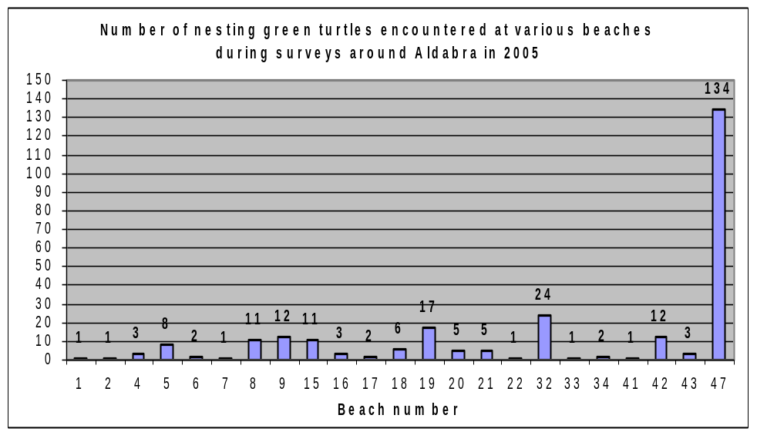
Figure 1.1: The number of nesting green turtles tagged at various beaches in 2005

Over the years, since 1996, the numbers of untagged (new) turtles encountered versus tagged individuals has varied between a maximum of 96. 8 % of new individuals in 1998 and a lower value of 60.4 % in 2005 (Table 2.3). In fact in recent years it seems that it is the proportion of older turtles that has increased being only 3% in 1998 to close to 40% in 2005. This trend is illustrated in figure 1.2.

Table 2.3. Proportion of new individuals encountered on beaches on Aldabra since 1996
Year | Total encounter | New | Old | % New
1996 | 229 | 211 | 18 | 92.1
1997 | 748 | 557 | 191 | 74.5
1998 | 308 | 298 | 10 | 96.8
1999 | 184 | 175 | 9 | 95.1
2000 | 307 | 212 | 95 | 69.1
2001 | 348 | 272 | 76 | 78.2
2002 | 129 | 101 | 28 | 78.3
2003 | 246 | 186 | 60 | 75.6
2004 | 206 | 156 | 50 | 75.7
2005 | 460 | 278 | 182 | 60.4

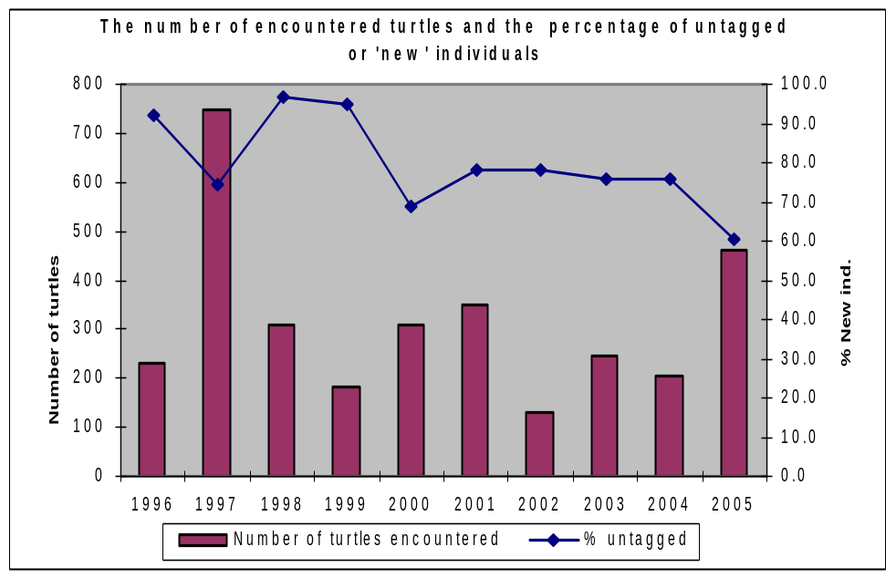
Figure 1.2: The number of turtles encountered and the corresponding percentage of
untagged individuals over the years

2.1.2 Juvenile green turtles

In total in 2005, 165 turtles were manipulated by rodeo (Table 1.1) above. 120 manipulation occurred on new turtles ( 72.7%) and 45 on old turtles (27.3%).

In 2005, during “Rodeo” of the 45 recaptured juvenile green turtles, one was tagged in 2000, one in 2002 and twelve in 2004. All the others were tagged and recaptured in 2005.

2004 57 recaptured juvenile green turtles, one was tagged in 2001, one in 2002 and 18 in 2003. The large majority (65%) of the turtles were captured at Ile Moustique. The shallow, clear water and sandy conditions around this lagoon island are favourable for rodeo activities. Even though so many turtles were tagged around Ile Moustique, the percentage of untagged individuals between the capture locations is fairly constant (figure 1.3). This suggests that juveniles move between these locations indeed, a few turtles that were captured at Ile Esprit were recaptured at Ile Moustique (and vice versa).

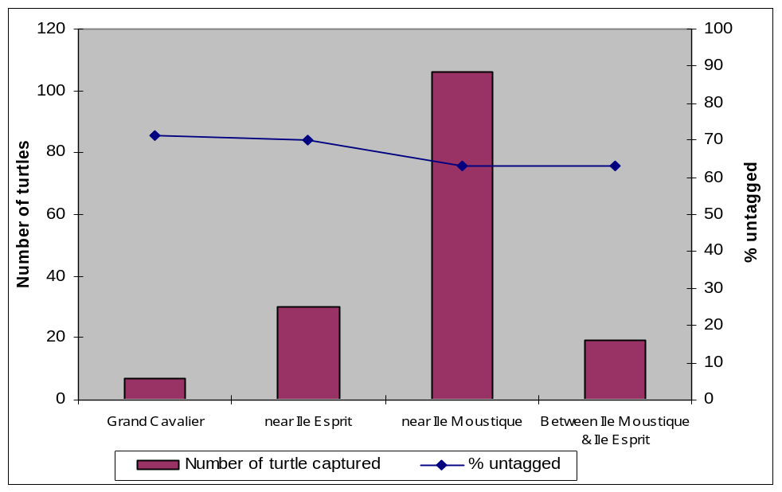

Figure 1.3: The number of juvenile turtles captured at the various rodeo locations and the
corresponding percentage of untagged individuals over the years

2.2 Track counts
Figure 1.7 shows the number of track counts conducted at each of the 47 ‘outer rim’ beaches in 2004. The frequency of counts is roughly in line with the required minimum (Mortimer 1997). Extrapolating from the sum of the settlement beach and West Grande Terre counts, 2004 provided average numbers of nesting green turtle emergences (in relation to the last 6 years). The high numbers of turtles recorded in 2001 is yet to be surpassed. Only 3 Hawksbill tracks were recorded on lagoon beaches.

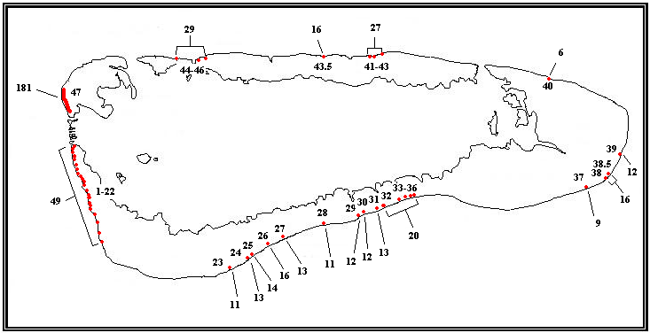
Figure 1.7: The number of track counts conducted per beach. 1-22, West Grande Terre; 23-27, Dune
D’Messe region; 28-36, Dune Jean Louis region; 37-39, Cinq Cases region; 40, Anse Cedres;
41-43.5, Anse Malabar region; 44-46, Gionnet region; 47, settlement beach

At the settlement and West Grande Terre beaches, nest site selection has followed similar annual patterns. At the settlement beach, nesting frequency increases with an increasing distance from the station and at West Grande Terre, turtles favour the larger and more stable beaches (figure 1.8).

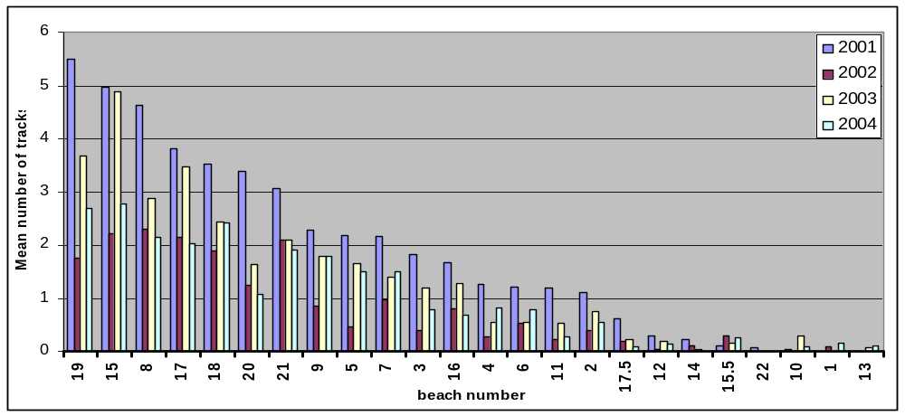

Figure 1.8: mean number of VF tracks per beach 2000 - 2004

Over the last 6 years, nesting seasonality has not followed the bi-modal pattern as reported in earlier years (Mortimer et al). At the settlement beach a single peak during March/April has been evident since 1999, (with the exception of 2000 where no seasonality occurred) confidence intervals show that this seasonal pattern is well established (figure 1.9). The West Grande Terre beaches show more variability in annual nesting seasonality. Nevertheless, at least the last two years seem to be conforming to the single March/April peak pattern (figure 1.10).

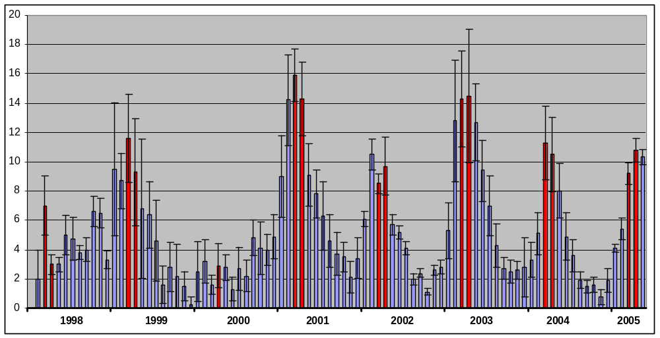
Figure 1.9: Monthly mean numbers of VF tracks on the settlement beach between 1998 and
May 2005 showing 95% confidence intervals. Red columns represent the months
of March and April.

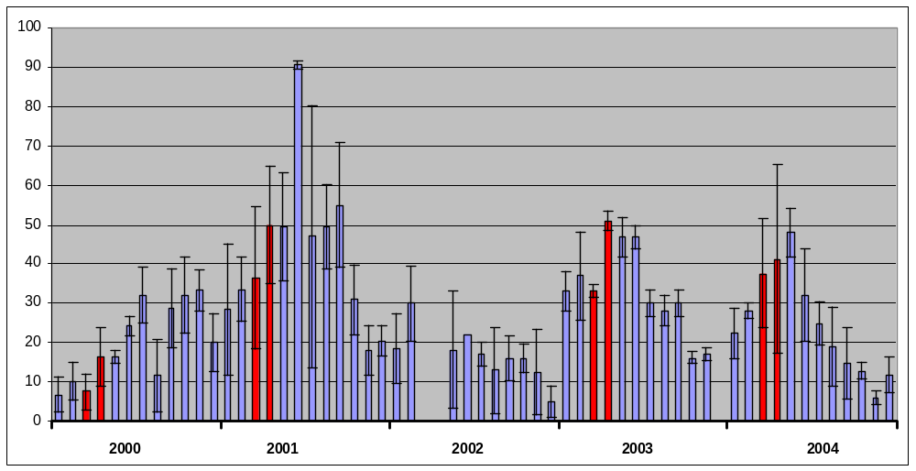

Figure 1.10: Monthly mean numbers of VF tracks along West Grande Terre beaches
between 2000 and 2004 showing 95% confidence intervals. Red columns
represent the months of March and April.

TURTLE TRACK COUNT

All track counts were conducted according to the monthly minimum frequency. At settlement beach, Over the year the monthly mean number of track per night varied from low value in January (4.1) to maximum in April (10.8) and subsequently decreased to low values in September and October (each 3.5 track per night). During the 2 last months of the year, the mean number increased to reach 7.7 tracks per night in December.

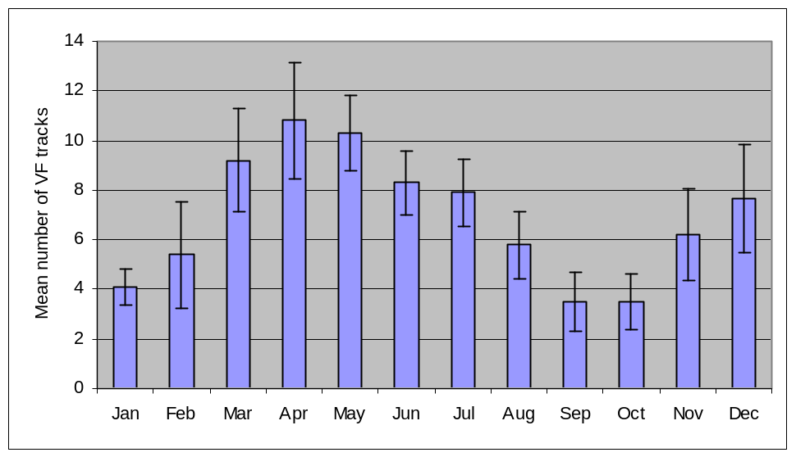
Figure 1: Monthly mean number of Green Turtle very fresh tracks at settlement beach Aldabra during 2005, with 95% confidence intervals.

2.1.3 Inaccuracy of morphometric measurements
On inspection of the tagging data, it was noted that a high degree of inaccuracy between morphometric measurements of the same individuals was evident. In order to test this assumption, measurements of turtles that were measured more than once during 2004 were compared. An ‘inaccuracy index’ was calculated through the division of the difference of like measurements by the larger of the two measurements.
Specifically: inaccuracy index = (x¹ - x² / xmax) * 100. The 2003 data was dealt with in the same manner in order to facilitate a comparison between the two years. For nesting green turtles a 186% increase in inaccuracy was found from 2003 to 2004. In other words, tagging personnel were three times less accurate when measuring turtles in 2004. Figure 1.4 shows that the ‘tip to tip’ and ‘width’ measurements were taken with particularly poor accuracy (see figure 1.6 for description of measurement parameters). For juvenile turtles, an increase of 48% in inaccuracy was found (i.e. measurements in 2004 were half as accurate as in 2003). From figure 1.5, tagging personnel were particularly careless with both the ‘over the curve’ and ‘straight line’ width measurements.
It must be noted that this is not attributable to a lack of training as accuracy improves dramatically when some supervisory pressure is applied. I believe that these shortcomings and the majority of other careless errors are based on a lack of concern rather than a lack of adequate training.

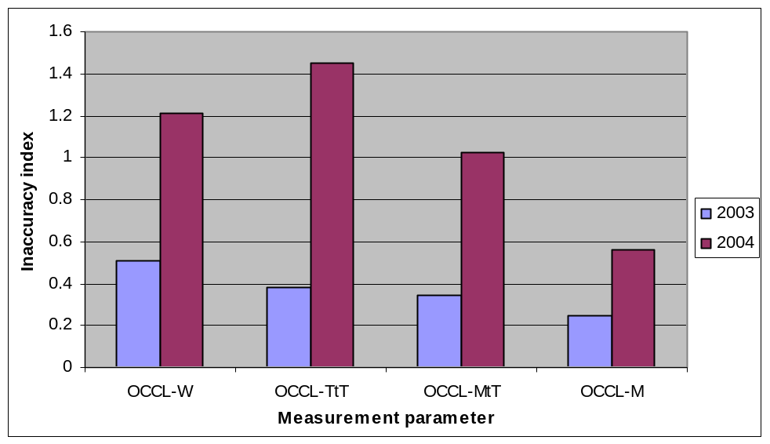

Figure 1.4: Mean inaccuracy indices for nesting green turtle carapace measurements in 2003
and 2004 (OCCL = ’Over the curve’)
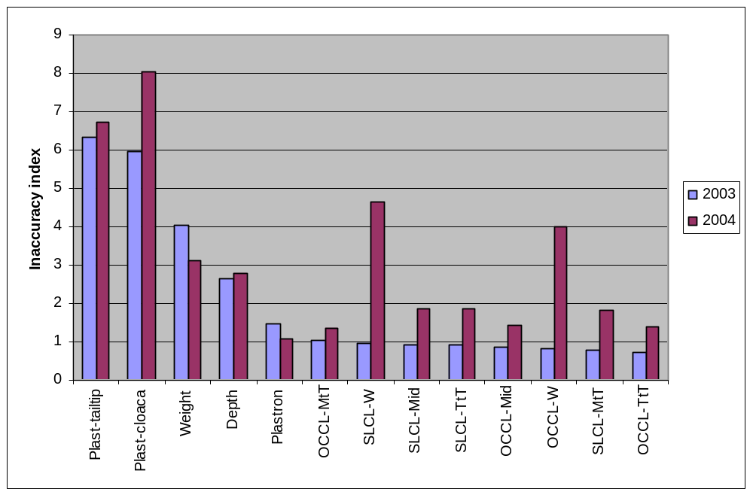

Figure 1.5: Mean inaccuracy indices for juvenile green turtle morphometric measurements
for 2003 and 2004 (OCCL = ‘Over the curve length’, SLCL = ‘straight line
length’)

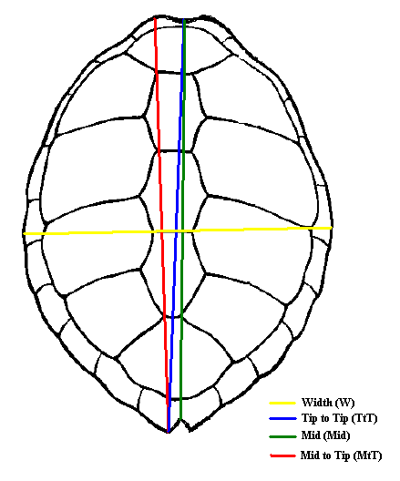

Figure 1.6:Carapace measurements of nesting and juvenile green turtles (nesting turtles only
OCCL, juvenile turtles OCCL + SLCL)

3. Tortoises
3.1 Introduction

In 2005, all tortoise transects ( Figure 2.1) were completed on a monthly basis.

Two population models were introduced to standardise data entry and reporting formats, one model was developed by David Bourn (david.bourne@ntlworld.com) and the other was developed by Rainer Von Brandis (holdevb@mweb.co.za). Strictly speaking, both programs are better described as ‘self-analysing databases’ as the term ‘model’ usually refers to a system that includes some form of predictive output. Neither Bourn’s nor the ‘Von Brandis model’ makes predictions; they simply provide a simple system of data entry and automatic analysis of data. Nevertheless -for the sake of continuity and simplicity- I will continue to refer to both programs as ‘models’.
The major difference between the models is that Bourn’s model derives actual population estimates whereas the ‘Von Brandis model’uses an index of tortoise numbers to describe trends. In Bourn’s model, tortoise population estimates are generated for each vegetation type by multiplying the average density of tortoises found in all sampled sections of that vegetation on an island over a specified period of time, by the total area of that vegetation (Bourne & Goodridge 2004). There are two considerable, and possibly detrimental, assumptions to this approach namely: 1) that transects are representative samples of the various vegetation types on the atoll and; 2) that tortoises are evenly distributed throughout each vegetation type. It is unlikely that assumption 1 holds true as all transects (except for those situated in naturally open areas) have, to some degree, been cleared of vegetation to create a passage for observers to move along (see adjoining pictures on this page). This has created favorable, artificial habitat for tortoises and has undoubtedly resulted in a misrepresentation of actual numbers in the corresponding vegetation types. For instance, in the Pemphis vegetation it is virtually impossible to move about without clearing the way with a machete. Much of the larger Pemphis stands around the atoll have exceedingly low tortoise densities. However, because an artificial path has been created for the tortoises, numbers are probably overestimated in this vegetation type. Indeed, Bourn’s estimates in the Pemphis vegetation between 1998 and 2003 range between 7000 and 12000. Even though actual population estimates are more ‘meaningful’ to the reader at first glance, it may not be the best approach.
The “Von Brandis model” has one major (and possibly detrimental) assumption namely that shifts in tortoise numbers along transects represents actual shifts in the population on that island as a whole. Fundamentally, this assumption correlates with Bourn’s however, the assumption that the vegetation along transects represents actual vegetation types on that island, is eliminated. The “Von Brandis model” was created not with the intention of providing population estimates, but rather to identify and describe trends in numbers along transects. Transect sections are not divided into their various vegetation types and used for extrapolation, rather, each transect is treated as a ‘stand alone’ unit. A ‘threshold of potential concern’ was applied with the intention of providing managers with a threat analysis based on the consistency, degree and the reliability of potential declines in annual tortoise numbers along each transect. For instance, a continuous decline in tortoise numbers along all six transects on Grande Terre would exemplify a high level of concern whereas poor similarity in trends would suggest the opposite. Further information regarding model development and functioning can be obtained from the SIF on request.
As far as the actual software is concerned, we have not been able to generate population estimates or routine reports from Bourn’s model. Apparently multiple copies of the program were transferred between computers (Station staff pers. comm.) and it is likely that an internal link between files has been broken. Nonetheless, graphs depicting monthly and quarterly results per transect are still displayed (but cannot be exported in report format) and show identical results to that generated by my model. Both models are therefore sorting and analyzing data correctly at the bottom end (this is important because an error at the bottom end of the analysis is detrimental to the final results). Since I am not able to generate reports from Bourn’s model, I was not able to include the results in this report. All results displayed below are copied directly from my model which has been functioning without incident. A complete copy of Bourn’s model findings will be forwarded to the SIF as soon as the software is repaired. Bourn’s model provides excellent reporting procedures and it will take a matter of a few minutes to generate the report and send it to SIF.

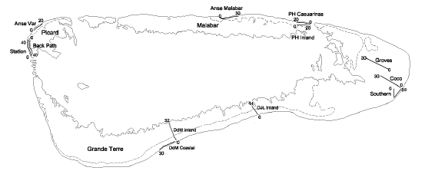

Figure 2.1: The location and relative length of tortoise transects around the atoll
(from Bourne 2004)

Tortoise transects are composed of section of each 10m?. On Picard island there are 3 Tortoise transect (Figure 2.1.) The coastal and back path transects are of 40 sections each and Anse Var of 20 sections. On Grande Terre 6 transects exist 2 at DJL (30 and 32 sections) 1 at DJL (34 sections). In the Cinq Case area (the coastal has 30 sections, coco has 30 sections and Groves 30 as well. On Malabar one transect at Malabar camp has 30 sections and 2 at Middle camp the coastal having 20 sections and the inland 30.

3.2 Model results –threat analysis and annual trends per transect
Due to the high volume of tables and graphs displayed by the model, only selected material is displayed in this report.

Furthermore, seasonal patterns in numbers and other well established demographical phenomena will not be revised here. A copy of my full model will be forwarded to the SIF in digital format as an addendum to this report. Readers wishing to view query related results directly from the model should request a copy of the digital version from the SIF.

3.2.1 Grande Terre
3.2.1.1 Groves transect
Tortoises numbers along the groves transect seem to be oscillating between a minimum of 224 in 2000 and a maximum of 349 tortoises in 2003. In 2005 the number of tortoises counted was 240. In 2000 the threat analysis tool assigned a level 1 concern to the declining trend and then returned to a ‘threatless’ situation in 2001 when the trend was reversed.

Table 2.1: Threat analysis –Cinq Cases Groves
Year | Concern level 1 | Concern level 2 | Concern level 3
1996 | no | no | No
1997 | no | no | No
1998 | no | no | No
1999 | no | no | No
2000 | YES | no | No
2001 | no | no | No
2002 | no | no | No
2003 | no | no | No
2004 | no | no | No
2005 | no | no | No

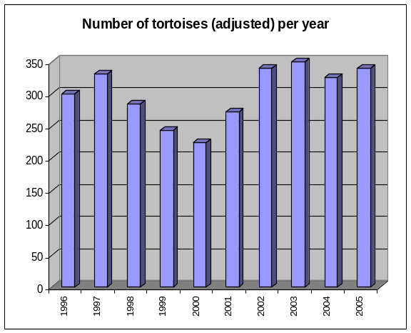 Figure 2.2: Annual trend in numbers –Cinq
Cases Groves
3.2.1.2 Coco transect
Similarly to the Groves transect, numbers showed a minimum of 612 in 2000 followed by a gradual recovery to a maximum of 1198 in 2004. In 2005 the number was 1092, a decrease that lead to Level one concern. Monthly tortoise counts followed the usual seasonal pattern with high values from January to May peak (Austral summer) and lower from June to December (Austral winter).

Fig Tortoises on the Coco transect Fig Tortoise turf on the Coastal transect

Table 2.2: Threat analysis –Cinq Cases Coco

Year | Concern level 1 | Concern level 2 | Concern level 3
1996 | no | no | no
1997 | no | no | no
1998 | no | no | no
1999 | no | no | no
2000 | YES | no | no
2001 | no | no | no
2002 | no | no | no
2003 | no | no | no
2004 | no | no | no
2005 | YES | no | no

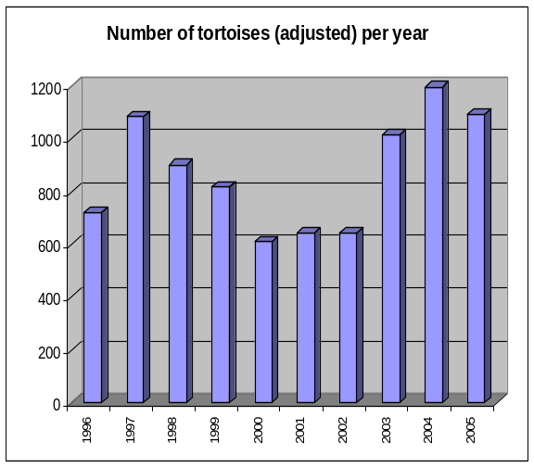 Figure 2.3: Annual trend in numbers –Cinq
Cases Coco

3.2.1.3 Coastal transect
In 2005 the number of tortoises counted on the Cinq Case coastal transect decreased to 426 from 451 in 2004, and created a Concern Level 1 (Table 2.3). Looking at historical trends a strong decrease in number was recorded in 1998, just less than half the tortoises encountered in the preceding year were recorded (level 1 concern). Then the trend was up until 2001 to drop in 2002. The upward trend from 2002 to 2004 did not continue in 2005 were the above mentioned drop occurred.

Table 2.3: Threat analysis –Cinq Cases Coastal

Year | Concern level 1 | Concern level 2 | Concern level 3
1996 | No | no | no
1997 | No | no | no
1998 | YES | no | no
1999 | no | no | no
2000 | no | no | no
2001 | no | no | no
2002 | no | no | no
2003 | no | no | no
2004 | no | no | no
2005 | YES | no | No

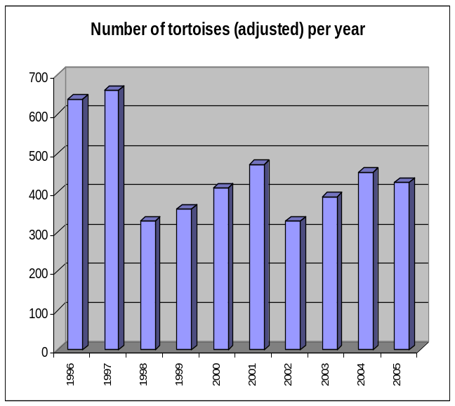
Figure 2.4: Annual trend in numbers –Cinq
Cases Coastal

3.2.1.4 Dune D’Messe coastal
Similarly to the Groves and Coco transects, the year 2000 saw a lower value compared to the values 3 previous years (Figure 2.5). As with the above mentioned transects, this declining trend lead to a level 1 concern by the model in 2000 (Table 2.4) . Seasonal variation in numbers followed the usual pattern. The decline in numbers from 1101 in 2004 to 946 in 2005 did not create a level of concern.

Table 2.4: Threat analysis –DDM coastal
Year | Concern level 1 | Concern level 2 | Concern level 3
1996 | no | no | no
1997 | no | no | no
1998 | no | no | no
1999 | no | no | no
2000 | YES | no | no
2001 | no | no | no
2002 | no | no | no
2003 | no | no | no
2004 | no | no | no
2005 | no | no | no

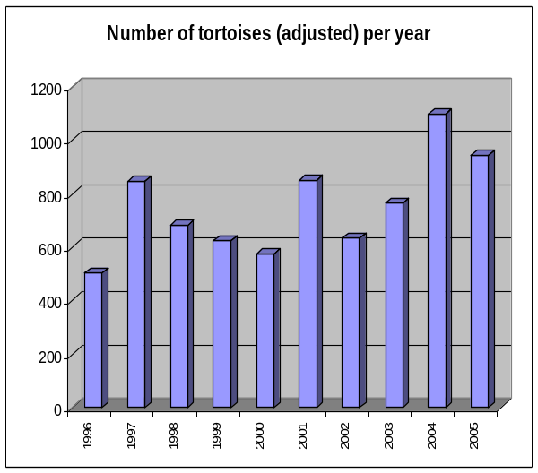
Figure 2.5: Annual trend in numbers –DDM
Coastal

3.2.1.5 Dune D’Messe Inland
A strong correlation exists between the trend on this transect and Cinq Cases Coastal (r = 0.82, p< 0.01). Similarly to the latter, numbers of tortoises have been variable over the years (r² = 0.25). In 1998 only 181 tortoises were counted decreasing to less than half the number of tortoises recorded in the preceding year, hence a level 1 concern was registered (Table 2.5). A level 1 concern was registered again in 2001 as numbers fell below that of 1998 to 163. However, since 2001, the numbers have been on the increase up to 251 in 2005.

Table 2.5: Threat analysis –DDM Inland

Year | Concern level 1 | Concern level 2 | Concern level 3
1996 | no | no | no
1997 | no | no | no
1998 | YES | no | no
1999 | no | no | no
2000 | no | no | no
2001 | YES | no | no
2002 | no | no | no
2003 | no | no | no
2004 | no | no | no
2005 | no | no | no
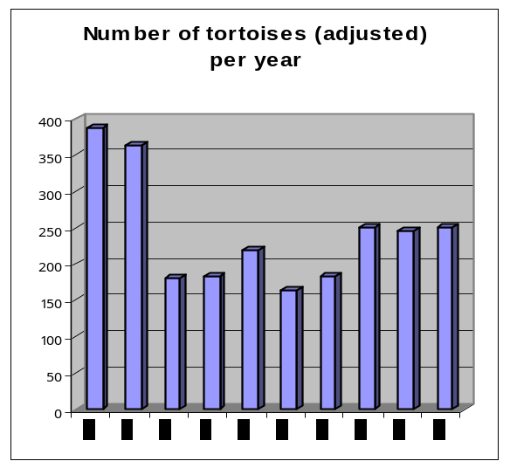
Figure 2.6: Annual trend in numbers –DDM
Inland

3.2.1.6 Dune Jean-Louis
The number of tortoises declined from 288 in 1996 to 190 in 2000 (Table 2.6.), similarly to the Coco, Groves and DDM coastal transects. For Dune Jean-Louis, however, the model assigned a level 2 concern in 2000 because the decline had been continuous for 5 years (rather than 4 –TPC calibration). After 2000, a change in trend direction was noted with values increasing up to 312 tortoise in 2004 to only decrease to 310 in 2005 (Figure 2.7).

Table 2.6: Dune Jean-Louis,
adjusted number of tortoises per year:
Year | No. of tortoise
1996 | 288
1997 | 259
1998 | 235
1999 | 190
2000 | 190
2001 | 257
2002 | 253
2003 | 256
2004 | 312
2005 | 310

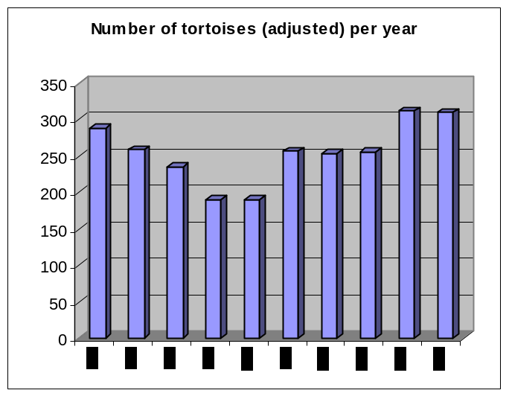
Figure 2.7: Annual trend in numbers –DJL

The threat analysis however shows strange results creating a threat in 2002 and in 2005 for just a variation of few individuals? ( study thwe definition of level). Also results differ with the 2004 threat analysis 1999 become a level 2 threat, and in 2002 also a level 2 threat appears for very similar data?

Table 2.7: Threat analysis –DJL 2005
Year | Concern level 1 | Concern level 2 | Concern level 3
1996 | no | no | no
1997 | no | no | no
1998 | no | no | no
1999 | YES | YES | no
2000 | YES | YES | no
2001 | no | no | no
2002 | YES | YES | no
2003 | no | no | no
2004 | no | no | no
2005 | YES | YES | no

Table 2.7: Threat analysis –DJL- 2004
Year | Concern level 1 | Concern level 2 | Concern level 3
1996 | no | no | no
1997 | no | no | no
1998 | no | no | no
1999 | YES | no | no
2000 | YES | YES | no
2001 | no | no | no
2002 | no | no | no
2003 | no | no | no
2004 | no | no | no

3.2.2 Malabar Island
3.2.2.1 Malabar transect

In contradiction to most of the Grande Terre transects, the year 2000 represented a peak in numbers. In 2004 no concerns were computed as the general tendency along this transect is one of increase. This tendency is confirmed by the 2005 values increasing to 468 tortoises .

Table 2.7: Threat analysis –Malabar transect
Year | Concern level 1 | Concern level 2 | Concern level 3
1996 | no | no | no
1997 | no | no | no
1998 | no | no | no
1999 | no | no | no
2000 | no | no | no
2001 | YES ? not in 2004 | no | no
2002 | No | no | no
2003 | No | no | no
2004 | No | no | no
2005 | No | no | no
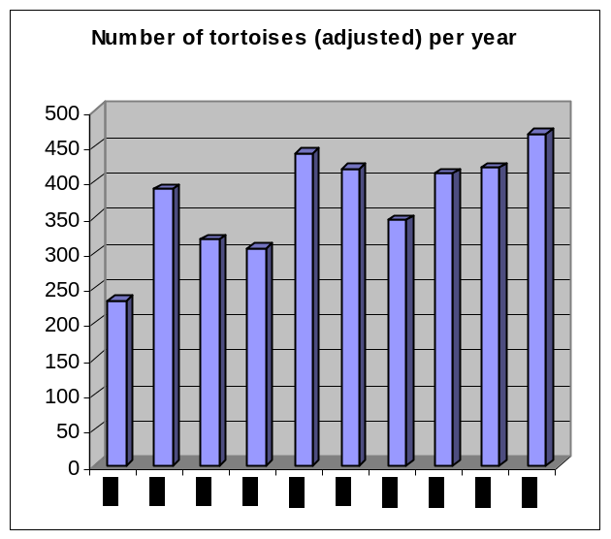
Figure 2.8: Annual trend in numbers -Malabar
transect

3.2.2.2 Middle Camp Inland

In 1996 379 tortoise were counted on the Middle camp inland transect, in the three following consecutive years the numbers have been decreasing to a value of 246 in 1999 creating a Level 2 of concern. However the subsequent year the number increased significantly to 369, but dropped again in 2001 to create a level 1 of concern. Subsequently numbers have been on the increase remaining above 300 in the last three years.

Table 2.8: Threat analysis –Middle Camp Inland
Year | Concern level 1 | Concern level 2 | Concern level 3
1996 | no | no | no
1997 | no | no | no
1998 | no | no | no
1999 | YES | YES | no
2000 | no | no | no
2001 | YES | no | no
2002 | no | no | no
2003 | no | no | no
2004 | no | no | no
2005 | no | no | no

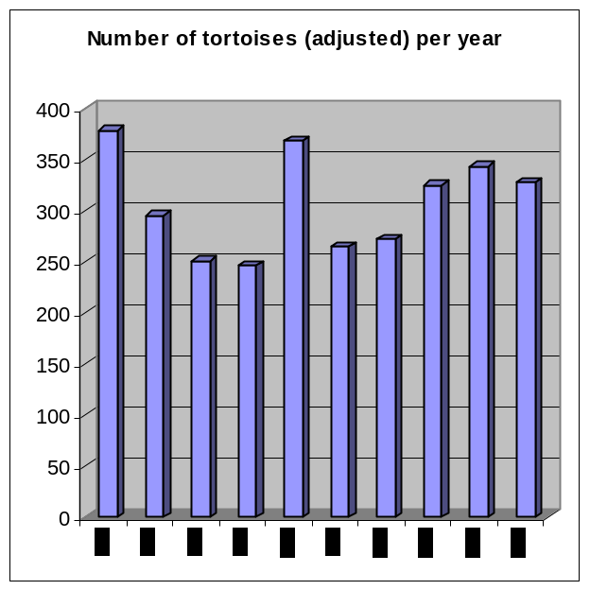
Figure 2.9: Annual trend in numbers –Middle
Camp Inland

3.2.2.3 Middle Camp Casuarina
The general trend shows first a decrease of the number of tortoises from 140 in 1996 to a low value of 76 in 2000 and then an continuous increase up to 175 tortoises in 2005. A similar peak in 2000 was observed at the Malabar transect. The peak in numbers in 2000 for the Middle Camp Inland and Malabar transects reflect the decrease in numbers along the Casuarina transect in that year. As a result of the emigration from this coastal transect to the inland transect in 2000, a level 1 concern was registered.

Table 2.9: Threat analysis –Middle Camp Casuarina
Year | Concern level 1 | Concern level 2 | Concern level 3
1996 | no | no | no
1997 | no | no | no
1998 | no | no | no
1999 | no | no | no
2000 | YES | no | no
2001 | no | no | no
2002 | no | no | no
2003 | no | no | no
2004 | no | no | no
2005 | no | no | no

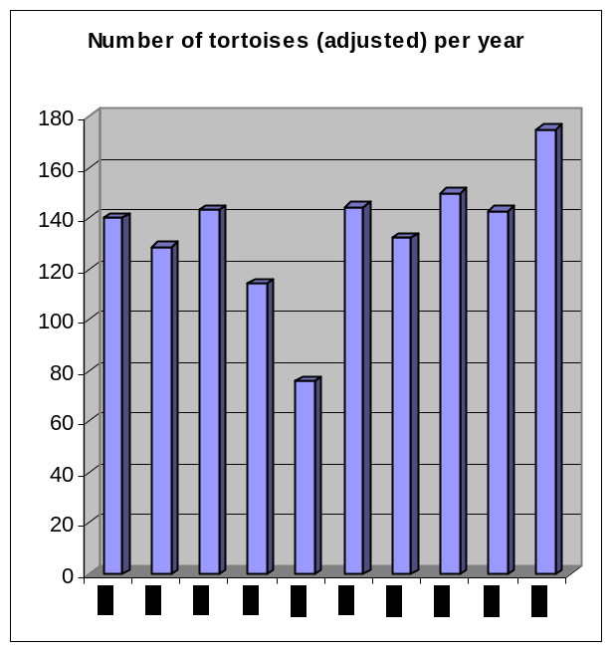
Figure 2.10: Annual trend in numbers –Middle
Camp casuarina

3.2.3 Picard Island
3.2.3.1 Coastal
In 1996 only 274 tortoises were counted on Picard coastal, in subsequent year however the values were all close or above 400 tortoises (Figure 2.11). In the last three years the numbers were above 500 tortoises with 594 tortoise in 2004 and 535 in 2005. A generally increasing trend in numbers is evident. No level of concern is reported for tortoises given the count on Picard coastal (Table 2.10). Seasonal variation during 2004 conformed to the established pattern (CHECK FOR 2005).

Table 2.10: Threat analysis –Picard Coastal
Year | Concern level 1 | Concern level 2 | Concern level 3
1996 | no | no | no
1997 | no | no | no
1998 | no | no | no
1999 | no | no | no
2000 | no | no | no
2001 | no | no | no
2002 | no | no | no
2003 | no | no | no
2004 | no | no | no
2005 | no | no | no

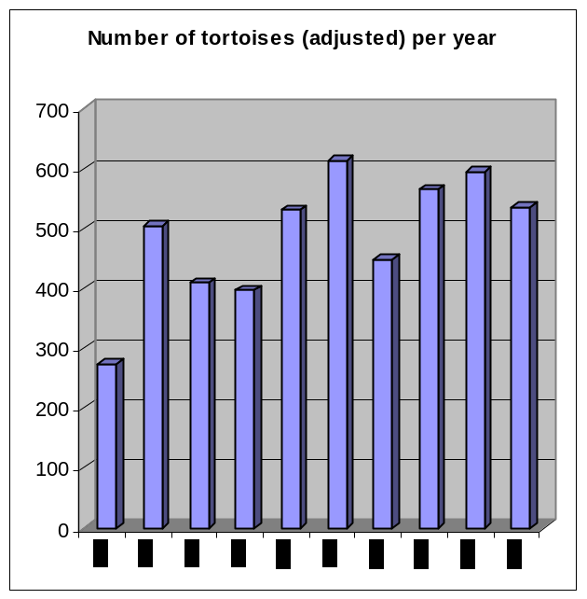
Figure 2.11: Annual trend in numbers –Picard
Coastal

3.2.3.2 Back Path
Since 2000 Numbers have been above 350 increasing to values above 450 in the three last years. The numbers increasing along a more stable linear trend (r² = 0.73). No reason for concern has been raised at any point. Adding the 2005 value appeared a concern for 2004 just because of 1 individual less in 2004 than 2003???? Does not make sense??

Table 2.11: Threat analysis –Picard Back Path

Year | Concern level 1 | Concern level 2 | Concern level 3
1996 | no | no | no
1997 | no | no | no
1998 | no | no | no
1999 | no | no | no
2000 | no | no | no
2001 | no | no | no
2002 | no | no | no
2003 | no | no | no
2004 | YES | no | no
2005 | no | no | no
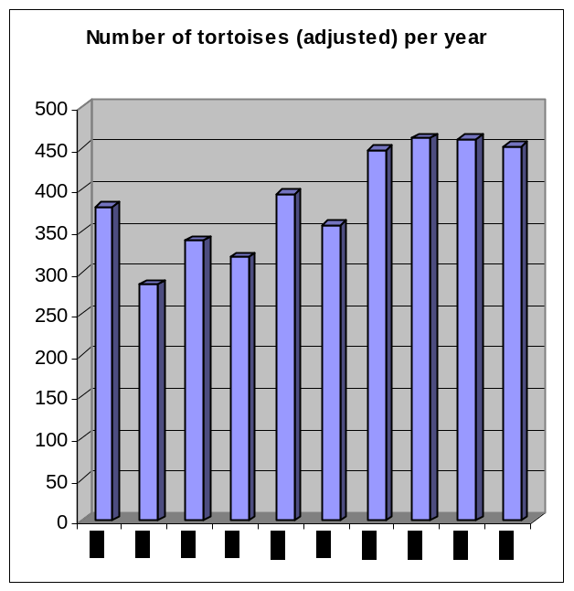
Figure 2.12: Annual trend in numbers –Picard
Back path

3.2.3.3 Anse Var
The steep decline between 1996 and 1999 raised a level 2 concern (Table 2.12). In the two subsequent years numbers increased to reach 139 tortoises in 2001. The decrease of the following year provided a Level 1 of concern, however, since then the trend seems to have reversed and even the decrease in 2005 as compared to 2004 did not lead to any level of concern.

Table 2.12: Threat analysis –Picard Anse Var
Year | Concern level 1 | Concern level 2 | Concern level 3
1996 | no | no | No
1997 | no | no | No
1998 | no | no | No
1999 | YES | YES | No
2000 | no | no | No
2001 | no | no | No
2002 | YES | no | No
2003 | no | no | No
2004 | no | no | No
2005 | no | no | No

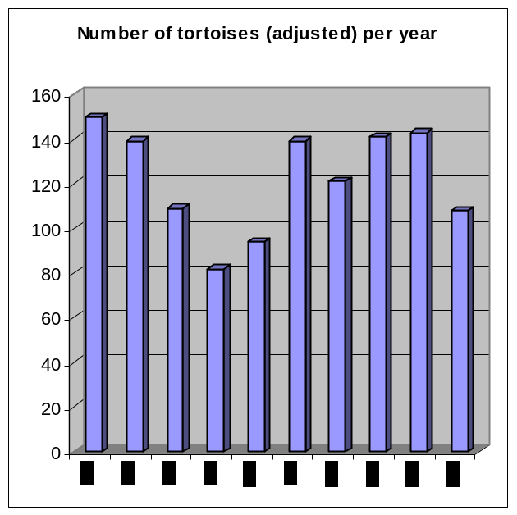
Figure 2.13: Annual trend in numbers –Picard
Anse Var

3.3 Discussion and further analysis on tortoise populations

3.3.1 Trends in numbers per island with future predictions
The total number of tortoises counted on each Island was calculated (Table 3.12).
Grande Terre has 6 transects while Malabar and Picard have three each. One could calculate the number of tortoise per transect on each of the different island.

Also the number of tortoise per meter of transect could be calculated!.

Table 2.13: Total number of tortoises counted on each of the three Islands on Aldabra since 1996.
Gde Terre | DJL | CC coastal | CC coco | CC groves | DDM coastal | DDM inland | Total
Year
1996 | 288 | 638 | 720 | 300 | 503 | 387 | 2836
1997 | 259 | 660 | 1086 | 331 | 846 | 364 | 3545
1998 | 235 | 327 | 903 | 285 | 680 | 181 | 2611
1999 | 190 | 359 | 817 | 244 | 626 | 182 | 2418
2000 | 190 | 413 | 612 | 224 | 576 | 220 | 2235
2001 | 257 | 472 | 643 | 272 | 851 | 163 | 2659
2002 | 253 | 329 | 645 | 339 | 633 | 183 | 2380
2003 | 256 | 389 | 1016 | 349 | 765 | 250 | 3025
2004 | 312 | 451 | 1198 | 326 | 1101 | 245 | 3633
2005 | 310 | 426 | 1092 | 340 | 946 | 251 | 3365
Malabar | A. Mal | MC inland | MC Coastal | - | - | - | Total
Year | 1 | 2 | 3 | - | - | -
1996 | 233 | 379 | 140 | - | - | - | 752
1997 | 389 | 296 | 129 | - | - | - | 814
1998 | 319 | 251 | 143 | - | - | - | 713
1999 | 307 | 246 | 114 | - | - | - | 667
2000 | 441 | 369 | 76 | - | - | - | 885
2001 | 419 | 265 | 144 | - | - | - | 828
2002 | 345 | 272 | 132 | - | - | - | 750
2003 | 411 | 325 | 150 | - | - | - | 886
2004 | 419 | 344 | 143 | - | - | - | 906
2005 | 468 | 328 | 175 | - | - | - | 971
Picard | A. Var | Back path | P. coastal | - | - | - | Total
Year | 1 | 2 | 3 | - | - | -
1996 | 150 | 379 | 274 | - | - | - | 803
1997 | 139 | 286 | 505 | - | - | - | 930
1998 | 109 | 338 | 409 | - | - | - | 856
1999 | 82 | 319 | 397 | - | - | - | 798
2000 | 94 | 395 | 531 | - | - | - | 1020
2001 | 139 | 357 | 614 | - | - | - | 1110
2002 | 121 | 448 | 448 | - | - | - | 1018
2003 | 141 | 462 | 565 | - | - | - | 1168
2004 | 143 | 461 | 594 | - | - | - | 1198
2005 | 108 | 452 | 535 | - | - | - | 1095
Figure 2.16: Total number of tortoises counted on Picard and Malabar per annum

Taking into account that there are 6 transects on Grande Terre it is not surprising that we have a higher count there. We looked into the number of tortoise per transect and obtained the following numbers. On Grande Terre the average tortoise number per transect is 478 tortoises (Figure 2.17) counted per transect. On Malabar 272 tortoises per transect and on Picard 333 tortoise per transect.

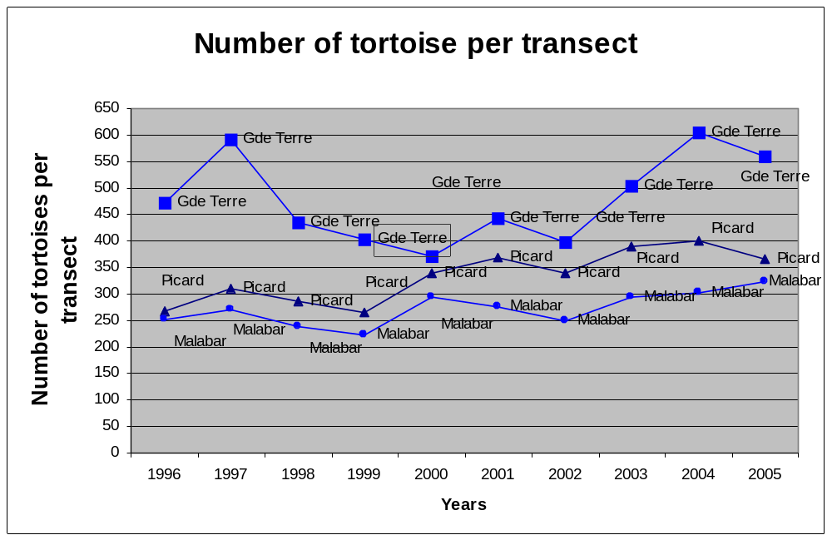
Figure

To predict future counts of tortoise on each island, we looked at the linear fit of the data.

For each island we calculated the linear regression. Also in certain case we investigated if there was a reasonable fit by the exponential curve. Two types of linear regression equations where calculated, one based on the years for which we observed values (1996- 2005) and one long term based on extrapolation in time of the data starting in 1980 up to 2020. The second one is used to make prediction on future number of the population In the first equation the variable x is equal to 1 when the year is 1996, 2 when the year is 1997 etc. In the second case x = to 1 in 1980 and 21 in year 2000.

3.3.1.1 Grande Terre
The total number of tortoise counted on Grande Terre fluctuated between 2235 and 3365.
For Grande Terre the linear regression gives a poor fit to the data (R² = 0.0804). There is no exponential trend in the data. Therefore neither of the two linear equations provides significant fit to the number of tortoises counted on transects.

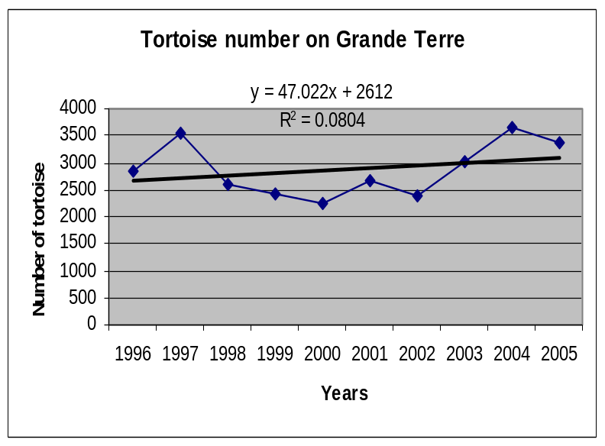

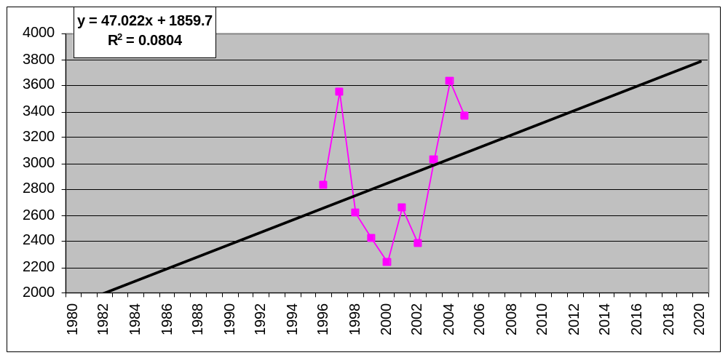
Figure 2.14: Total number of tortoises counted on Grande Terre per annum. Linear trend
line is insignificant

Between 1997 and 2000, a significant decrease in population numbers was reported (Bourne 1999). This concern is clearly reflected in figure 2.14, here above. However since 2001, numbers have been increasing to a point were the total number of tortoises counted in 2004 exceeded that of 1997 (figure 2.14). It is believed that the Grande Terre population might be in a state of equilibrium that is cyclic or chaotic (Bourne 1999) ?. This is reflected by the insignificance of the linear trend line expressed in figure 2.14. Consequently, it is not possible to make any reasonable predictions regarding future trends in population (COUNTS? ) numbers.
On four of the six transects, tortoise numbers ‘bottomed out’ in 2000. It is interesting to note that mean annual rainfall over the given period was lowest in 2000 (figure 2.15) and it seems plausible that low tortoise numbers on transects in that year are - at least to some degree - a consequence of little precipitation. Even though a significant decrease in rainfall may increase adult mortality (an immediate population response), it should have a greater effect on recruitment (delayed population response). It is therefore unlikely that the poor rainfall in 2000 resulted in an actual decrease in tortoise numbers as portrayed by figures 2,3,5 & 7. A more parsimonious explanation may be that, due to the fact that tortoises are less active during dryer periods (Gibson and Hamilton 1983) and because transects are cleared regularly to permit the passage of observers (less shade cover), fewer tortoises were encountered. In other words: tortoises were spending more time in the shady areas away from the more open transects and hence, less were counted. However to date there is no study to substantiate this hypothesis.

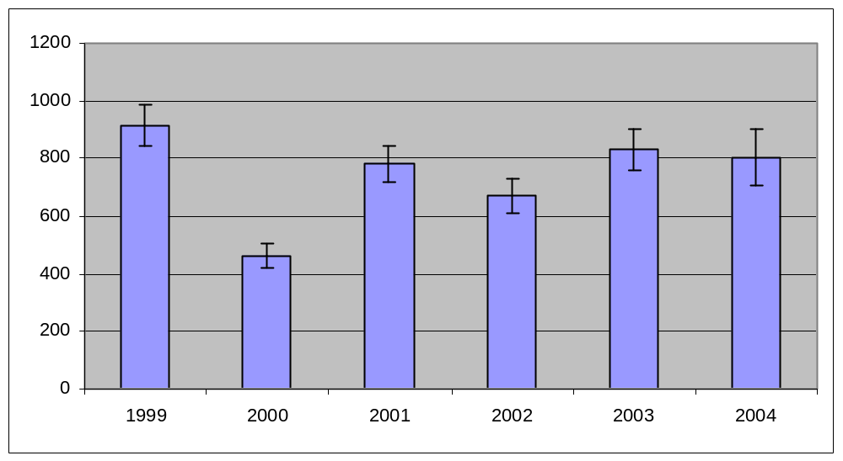
Figure 2.15: Mean annual rainfall at Aldabra. Years 1996 – 1998 omitted due to
incomplete records

3.3.1.2 Picard Island

For Picard, the linear trend (R² = 0.7428) better fits the data than the exponential fit (R² = 0.7296)

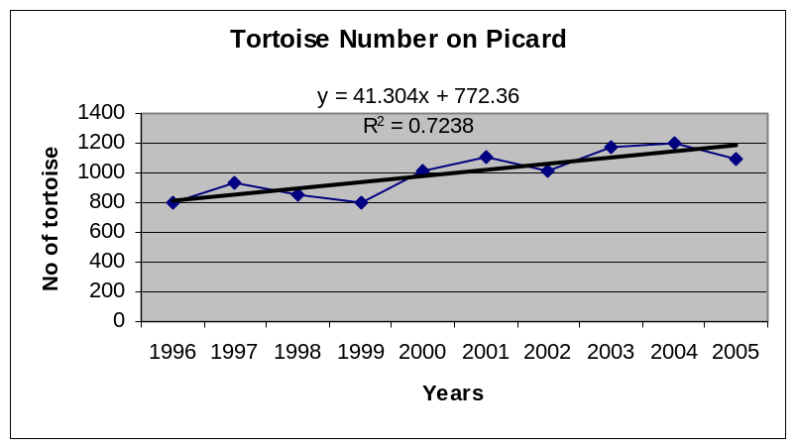

When we extrapolated the line over a long period of time starting in 1980 ( X= year = 1) the following linear equation is obtained and allows prediction for the future. For example in 2016 (X= 37) the tortoise population on Picard should be 45.82 * 37 + 6.1= 1700 tortoises.
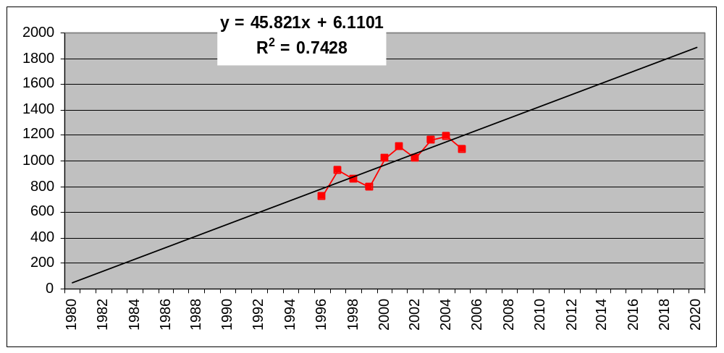
Figure 2.17: Total number of tortoises counted on Picard Island per annum. Linear
trend line is significant

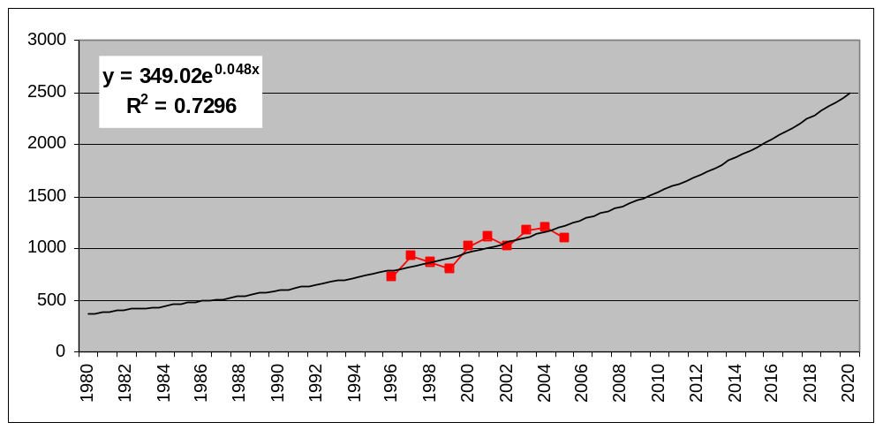
Figure 2.17: Total number of tortoises counted on Picard Island per annum. Exponential
trend line is also significant

In the past, the tortoise population on Picard was subject to overexploitation and it is quite clear that the population is still recovering. In contradiction to the Grande Terre population, tortoises are nowhere near carrying capacity and are therefore not regulated by density dependent factors. Population growth form in recovering populations should be exponential until density dependent factors begin to level out the trend.
There is a strong correlation between the annual numbers of tortoises counted on Picard and Malabar (r = 0.85, p< 0.01) (figure 2.16). This is to be expected because both populations are at low densities and are subjected to similar environmental factors within similar habitat types. Furthermore, the exponential trend line on Picard is significant (r² = 0.78, p< 0.05) (figure 2.17) and reflects the previously established increasing trend in tortoise numbers (Bourn 1999). On the basis of the above, it is reasonable to project numbers into the future along the exponential trend line. According to the exponential trend line equation, tortoise numbers on Picard should double by the year 2016. Note that no 95% confidence intervals can be calculated reducing the reliability of the projected trend markedly.

3.3.1.3 Malabar Island

Also for Malabar the linear trend (R² = 0.4898) better fit the data than the exponential than the exponential (R² = 0.4643).

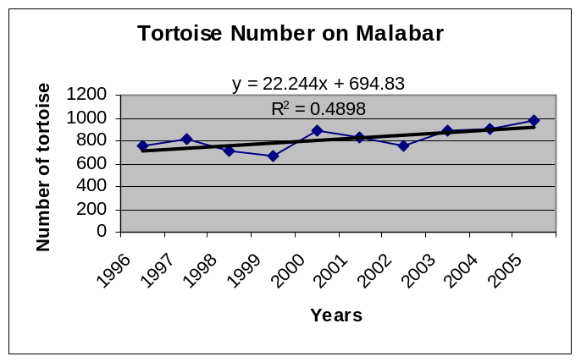

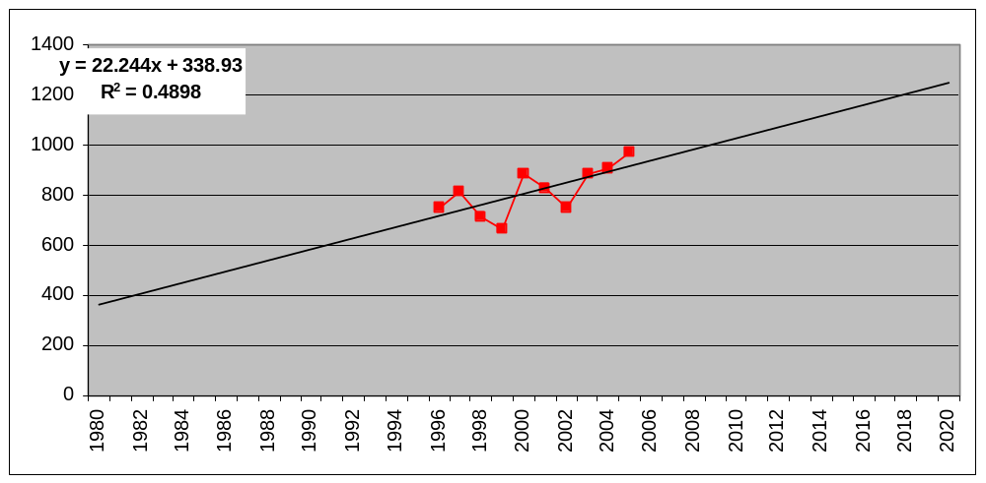

Similarly to the Picard population, tortoises on Malabar also seem to be recovering from previous overexploitation. When an exponential trend line is applied to the Malabar data, an insignificant relationship between time and total number of tortoises counted per annum is recognized. As a result, the exponential trend line depicted in figure 2.18 is insignificant.
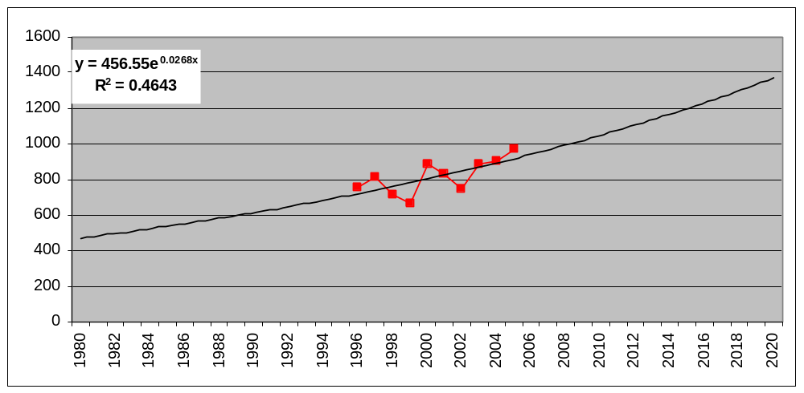
Figure 2.18: Total number of tortoises counted on Malabar Island per annum. Exponential
trend line is insignificant

In conclusion a LINEAR trend was find to be significant fit FOR Picard and Malabar not for Grande Terre.

3.3.2 Mean scute size
The curved length of the third dorsal scute can be used as an index of tortoise size (Bourne & Coe, 1976). The annual mean scute size was calculated for 2005 and is know for each transect and for every year since 1996 (Table 3.13)

Table 3.14: Length of 3_{rd} scute of tortoise from each transect between 1996 and 2005.
Transect | 1996 | 1997 | 1998 | 1999 | 2000 | 2001 | 2002 | 2003 | 2004 | 2005 | Mean
Pic. Coastal | 31.0 | 30.3 | 30.7 | 30.1 | 29.9 | 30.3 | 29.8 | 30.4 | 30.6 | 31.7 | 30.48
Pic. B. path | 28.4 | 28.0 | 29.1 | 29.3 | 28.5 | 28.4 | 29.3 | 28.5 | 29.0 | 29.5 | 28.79
Pic. A. Var | 25.2 | 26.5 | 26.8 | 26.7 | 27.3 | 27.2 | 27.0 | 27.7 | 27.8 | 27.9 | 27.02
Malabar cos. | 26.5 | 26.9 | 26.9 | 27.0 | 25.9 | 25.8 | 25.5 | 26.3 | 26.2 | 26.8 | 26.37
MC inland | 24.3 | 25.4 | 24.5 | 26.5 | 24.7 | 24.3 | 24.4 | 24.7 | 24.1 | 24.2 | 24.71
MC coastal | 20.0 | 25.9 | 25.1 | 24.9 | 19.6 | 23.5 | 24.0 | 23.6 | 24.2 | 25.2 | 23.60
DDM coastal | 20.5 | 20.4 | 20.4 | 20.9 | 20.6 | 20.7 | 20.3 | 19.9 | 20.1 | 20.1 | 20.37
DJL inland | 21.3 | 21.3 | 20.4 | 19.9 | 19.5 | 19.8 | 20.0 | 20.5 | 20.0 | 20.5 | 20.33
CC coastal | 19.4 | 19.8 | 19.9 | 20.0 | 19.6 | 19.8 | 19.7 | 19.8 | 20.0 | 20.0 | 19.81
CC coco | 19.5 | 19.5 | 19.5 | 19.3 | 19.2 | 19.2 | 19.0 | 19.1 | 19.3 | 19.3 | 19.29
DDM inland | 20.2 | 20.1 | 19.1 | 18.3 | 18.2 | 18.4 | 18.9 | 18.8 | 18.8 | 18.7 | 18.94
CC groves | 18.7 | 18.7 | 18.8 | 18.6 | 18.5 | 18.5 | 18.8 | 18.3 | 18.4 | 18.4 | 18.56

Mean scute sizes calculated by the model are in accordance with the established morphological variation between Islands. Picard Island clearly supports the largest tortoises with average size of the 3rd scute above 27 cm, followed by Malabar with the scute being above 23 cm. Tortoises of Grande Terre are of smaller sizes with the scute not reaching 20.5 cm on any transects. In particular the Cinq Case area and the DDM have small mean scute size, all situated between 18.5 and 19.5 (Table ) . The size difference between Islands is clearly shown in Figure 2.19.

Large body size is a characteristic specific to those tortoise populations that are not regulated by density dependent factors such as ( might be? ) the low-density populations on Picard and Malabar.

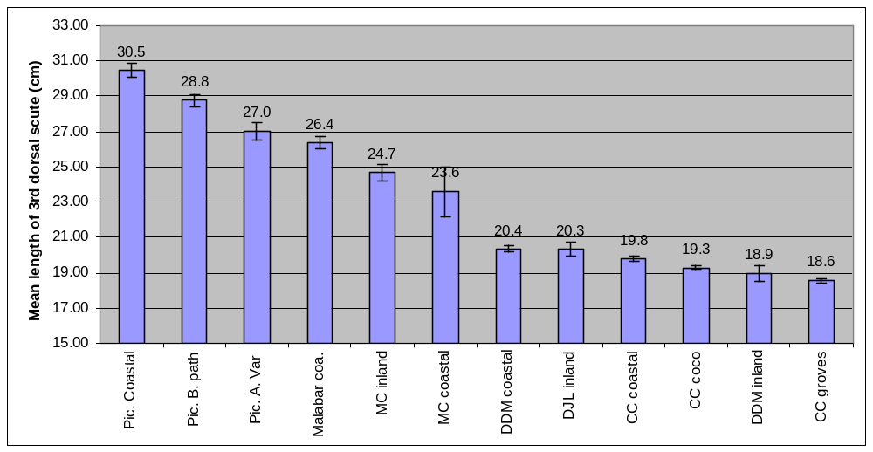
Figure 2.19: Mean scute size per transect (derived from pooled data 1996-2005)

It is postulated that mean scute size should decrease proportionately with a decrease in the availability of food and that in years to come, scute size could offer a potential index of population growth (numbers ?) on Picard and Malabar. Ref ?

At this point in time however, mean annual scute size is variable but no pattern can be assigned to the long-term trend (insignificant trend lines). Indeed no significant linear trend could be detected. Analysing the data per island no significant relation was found. Record on movement (Coe, Bourn & Swingland, 1979) have shown that while some animal do move large distances, 56% of the population are not relocated more than 500 m from their initial marking point. Taking into account that tortoises are slow moving animals and that their range is limited, we looked at transect situated in the same vicinity to detect any linear trend. For Picard, no significant linear trend was detected for the 2 transect situated along settlement beach. Indeed looking only at the 2 transects along the settlement area, the linear regression also provided a low level of signification (R² = 0.19) (Figure 2.20). Also for Middle camp transect, no significant linear relation was found between the mean scute size and time (R² = 0.008) (Figure 2.21) .

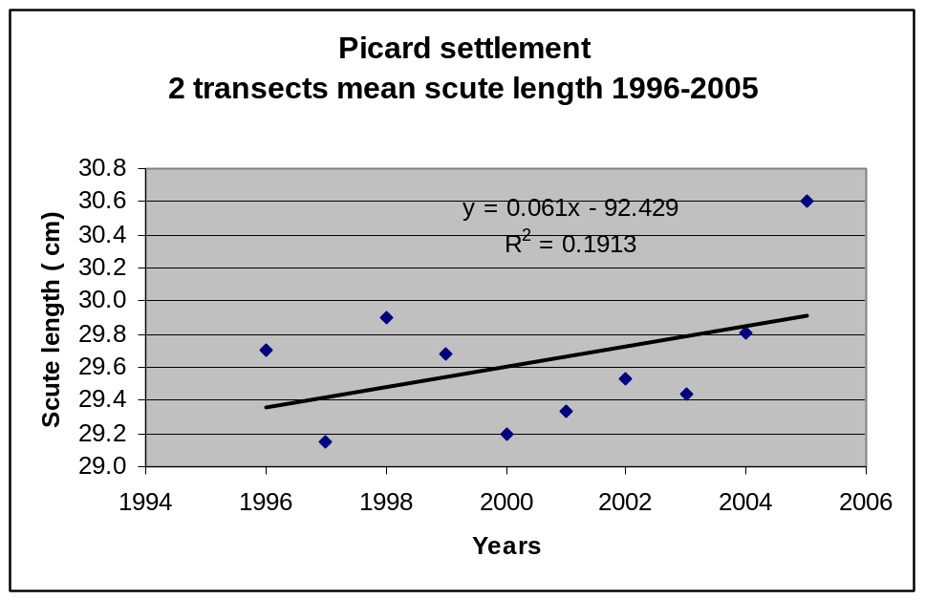
Figure 2.20: Picard settlement transects, linear regression and correlation

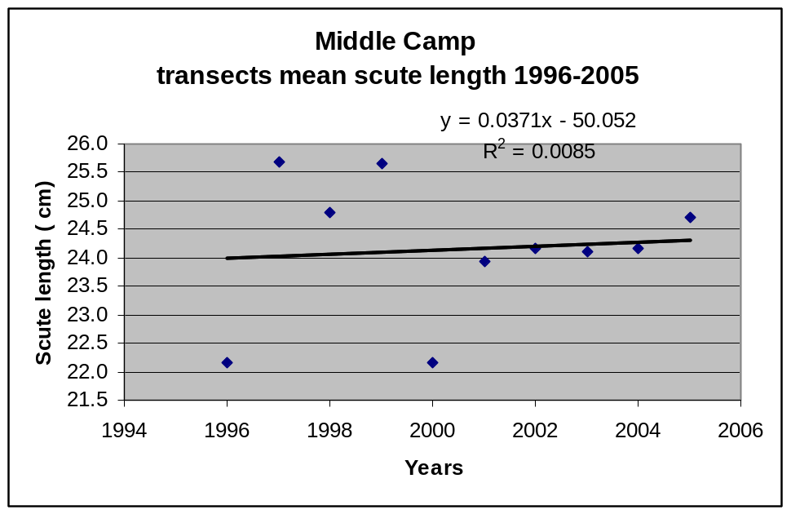
Figure 2.21: Middle Camp transects, linear regression and correlation between tortoise mean scute size and time.

However for the Dune De Messe area situated on the Southern part of Grande Terre, combining the inland and the coastal transects, we found a significant linear relation, indicating a decrease in the mean scute size of those tortoises (R² = 0.67) (Figure 2.22). The average scute size decreased from 20.3 cm in 1996 to 19.4 cm in 2005, almost 1 cm difference.

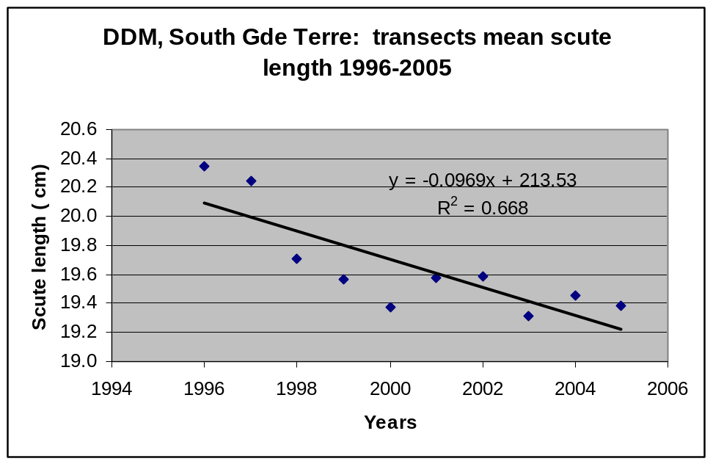
Figure 2.22: Dune De Messe transects, linear regression and correlation between tortoise mean scute size and time.

Also for the Cinq Case area the two inland transects are showing a significant decreasing linear relation between mean scute size and time (R² = 0.63) (Figure 2.23). The decrease over time is smaller here, only being of a few millimetres over the 10 years period.

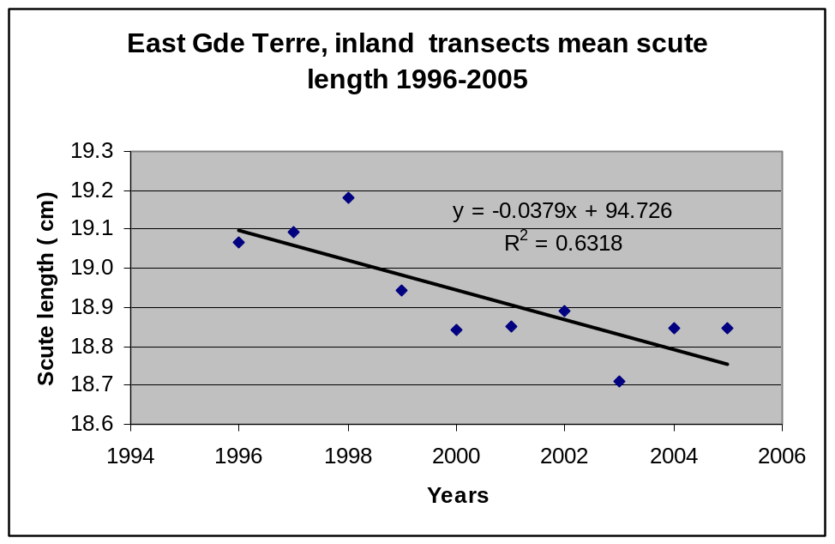
Figure 2.23 : Cinq Case area inland transects linear regression and correlation between tortoise mean scute size and time.

On Grande Terre the Dune Jean-Louis and Dune D’Messe inland transects showed significant variation in annual scute length along significant polynomial trend lines (figure 2.20). Furthermore, there is a strong correlation in pattern between the two trends (r = 0.95, p<0.001). The two population of tortoises have seen their mean scute length changing of about the same value in the same direction each year. I am not able to provide a rational explanation for this relationship.

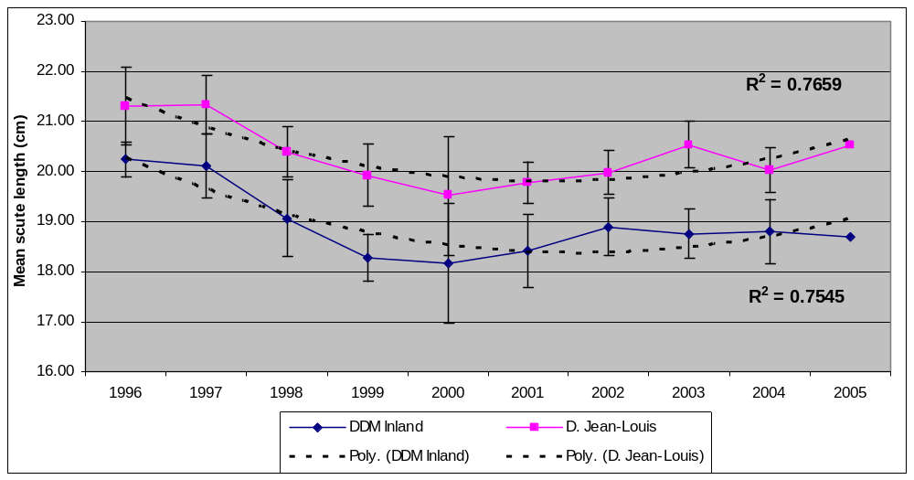
Figure2.20: Mean annual scute length for Dune D’Messe inland and Dune Jean-Louis
Transects (derived from pooled data 1996-2005. Polynomial trend lines are
Significant.

3.3.3 Sex ratios

Generally speaking for all transects combined, the proportion of female is higher than for males (Figure 2.21) . There is a high proportion of individual below 20 cm (40 % or more) but they are more frequent on certain Islands than other.

For a tortoise of less than 20cm scute length the sex is difficult to determine and are therefore recorded as “undetermined” or “unidentified”. On Grande Terre, where tortoises are of smaller sizes, mean scute size ranges between 18.5 and 20.4 cm and as a result, unidentified individuals constitute a larger proportion and include both adults and juveniles. On Picard and Malabar, where mean scute length ranges between 23 and 30cm, tortoises with less than 20 cm scute length can be classified as juvenile. It is interesting to note that on Picard, where tortoise numbers should be increasing at a faster rate than other islands, very few juvenile tortoises (less than 20cm scute length) were recorded (Figure 2.21). One wonder where are the small juvenile tortoise on Picard ?. On Grande Terre in the Dune Jean Louis area, juvenile tortoises of intermediary size are more frequently observed than on Picard.

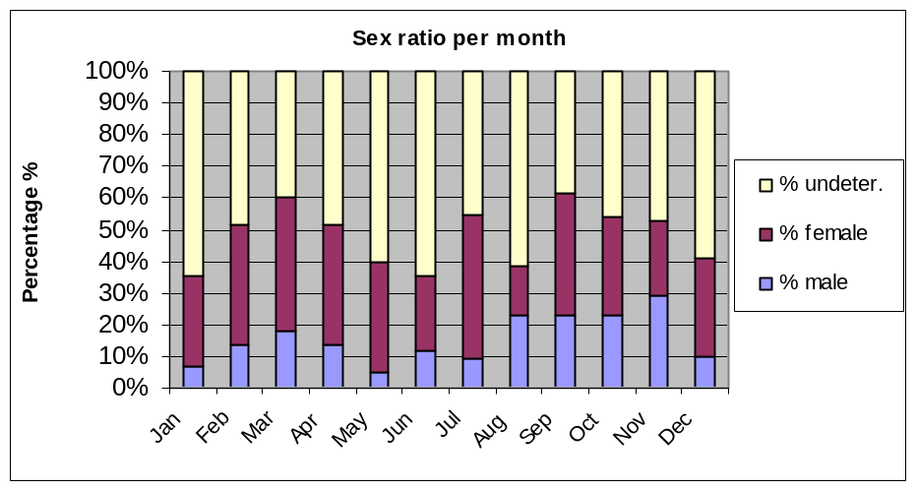
Figure 2.21: Sex ratios on the various transects during 2005

4. Birds
4.1 Land birds
Monthly land bird counts were conducted in 2005 along the 7 transects around the atoll (Table 3.1). The 2005 counts can be compared with the ones of previous years (2002, 20003, 2004 and 2005). Strong correlations between the annual number of sightings per species were found between 2002, 2003 , 2004 and 2005 (r = 9.9, 9.8, 9.9, 9,8).

A significant increase in land bird sightings in 2004 was calculated (F2,36 = 3.26, P< 0.05)

Table 3.1: The total number of land birds counted per annum on all transect since 2002
Species | 2002 | 2003 | 2004 | 2005
Souimanga Sunbird | 1497 | 1679 | 2255 | 2106
Madagascar Turtle Dove | 675 | 683 | 1016 | 861
Madagascar White-eye | 536 | 403 | 950 | 753
Madagascar Bulbul | 495 | 378 | 497 | 421
Comoro Blue Pigeon | 269 | 229 | 314 | 367
Aldabra Forest Fody | 108 | 200 | 243 | 224
Aldabra Drongo | 99 | 110 | 137 | 140
Aldabra Rail | 74 | 67 | 112 | 103
Madagascar Coucal | 44 | 38 | 13 | 20
Pied Crow | 45 | 13 | 35 | 21
Sacred Ibis | 34 | 24 | 32 | 45
Madagascar Kestrel | 17 | 13 | 24 | 15
Madagascar Nightjar | 2 | 1 | 2 | 1
Totals | 3895 | 3840 | 5630 | 5077

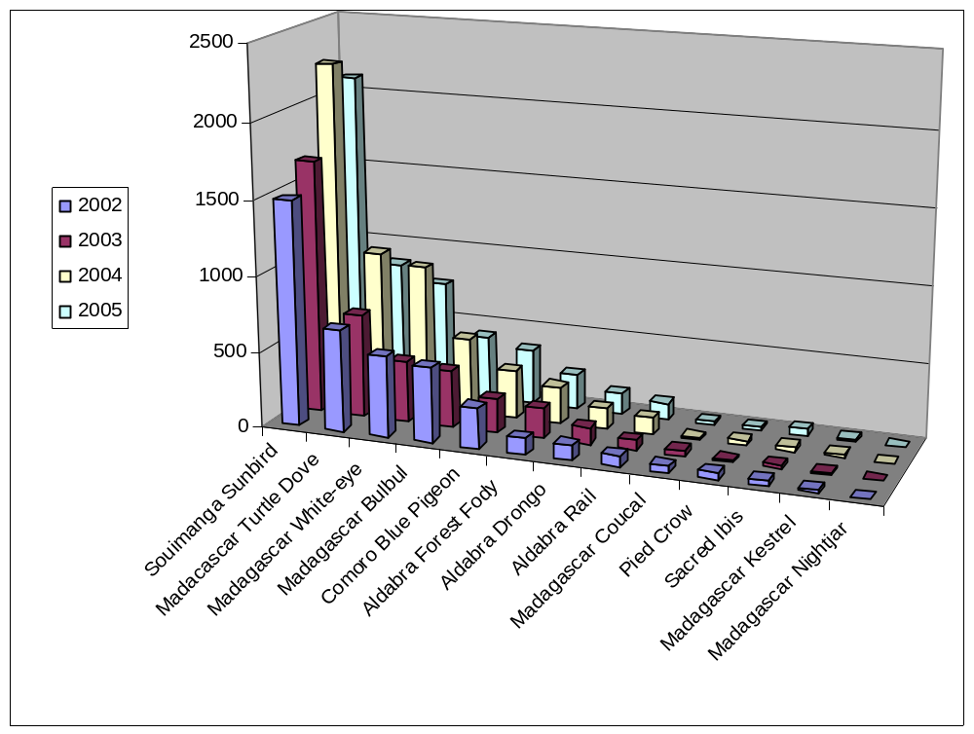
Figure 3.1: Total number of land birds per species from 2002-2005

Looking at the individual evolution of the counts for each species we investigated if the linear trend was increasing or decreasing for each of the species.

For the Souimanga Sunbird there is an increasing trend raising form 1500 counts in 2002 to more than 2106 count in 2005, (R2= 0.762)

The turtle dove shows a increasing trend from some 675 counts to 861, but the R2 is only 0.5

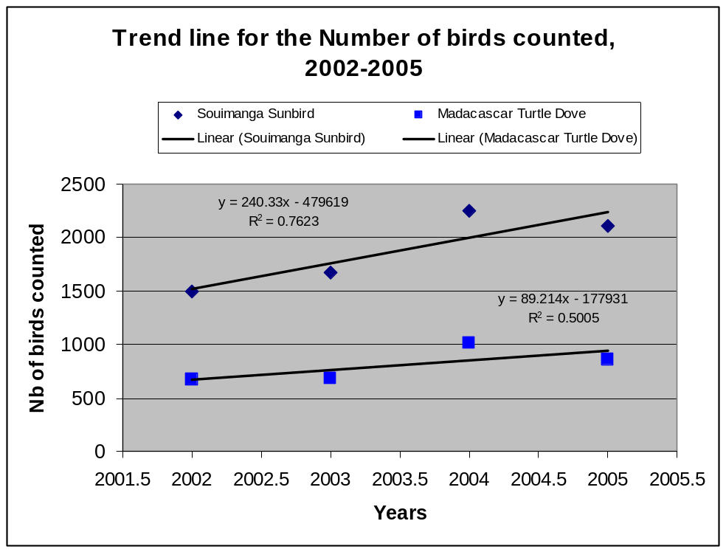

The Madagascar white eye also show an increasing trend in counts, but the coefficient of correlation is insufficient to be significant. The bulbul shows an decreasing trend but with a very low coefficient
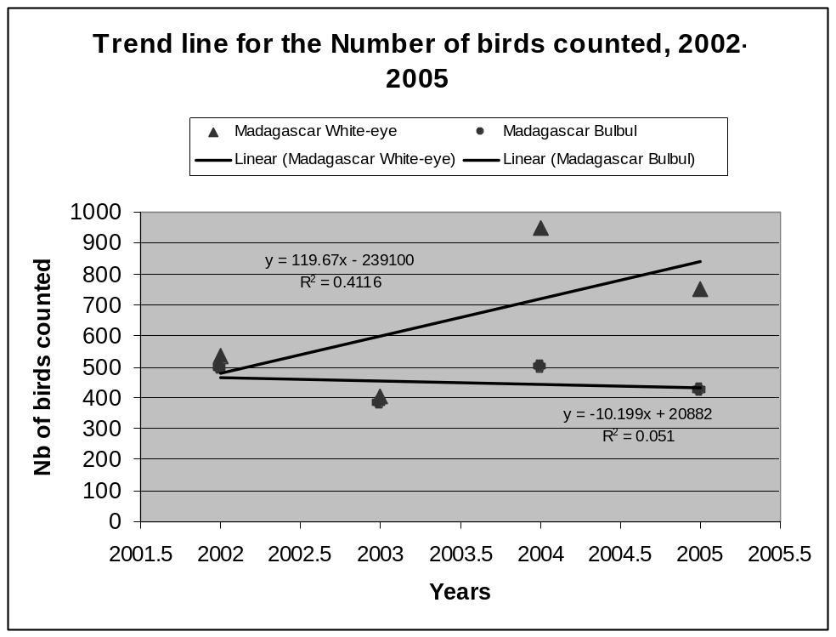

The Comoro Bleu pigeon shows an increasing trend with count of 269 in 2002 up to 224 in 2005 with a reasonable fit of the data to the increasing trend line (R2= 0.68). The Aldabra Fody also shows an increasing trend from 108 in 2002 to 224 in 2005 with a good fit of the data (R2=0.71).

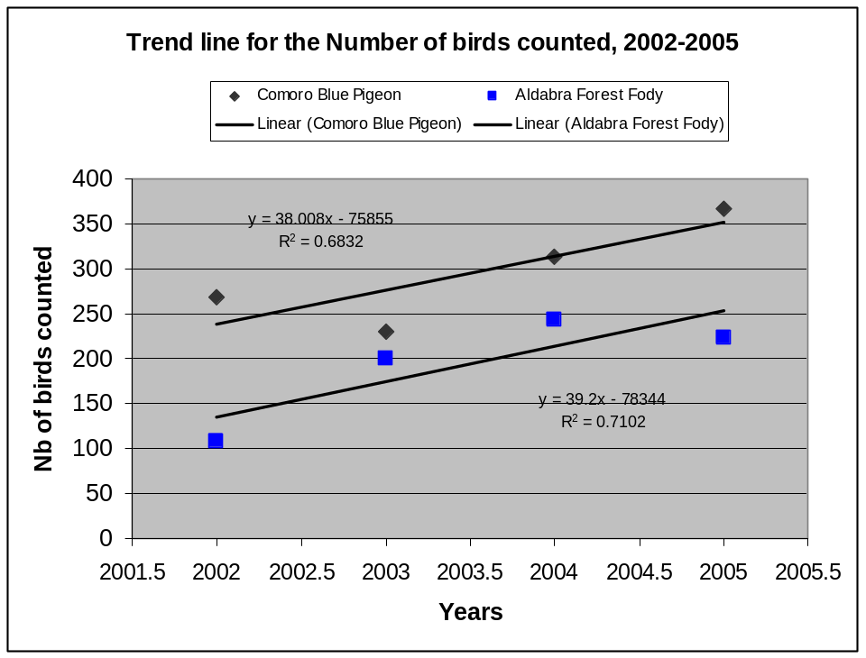

For the Aldabra Drongo, an endemic species of Aldabra, the counts increased from 99 in 2002 to 140 in 2005 with a clear increasing trend line a good fit of the data to the increasing trend line (R2= 0.92).

Also the Aldabra Rail as seen is numbers increasing from 74 to 103 and an increasing trend line fit the data reasonably well (R2= 0.6). Those findings are rather positives signs for the Drongo and the Rail population on Aldabra.

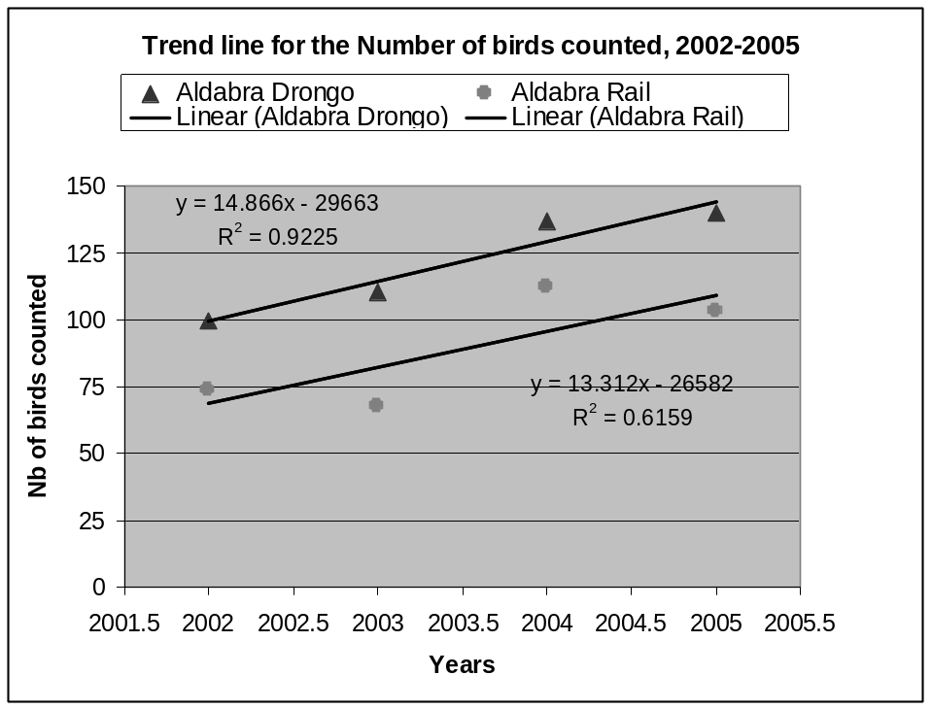

For the Madagascar Coucal, the counts have decreased from 44 in 2002 to 13 in 2004. However in 2005, the counts increased a bit as 20 Coucals were seen. (R2= 0.7)
Also the Pied Crows are seeing their counts decreasing form 45 to 21 however this trend is not significant as R2= 0.2.

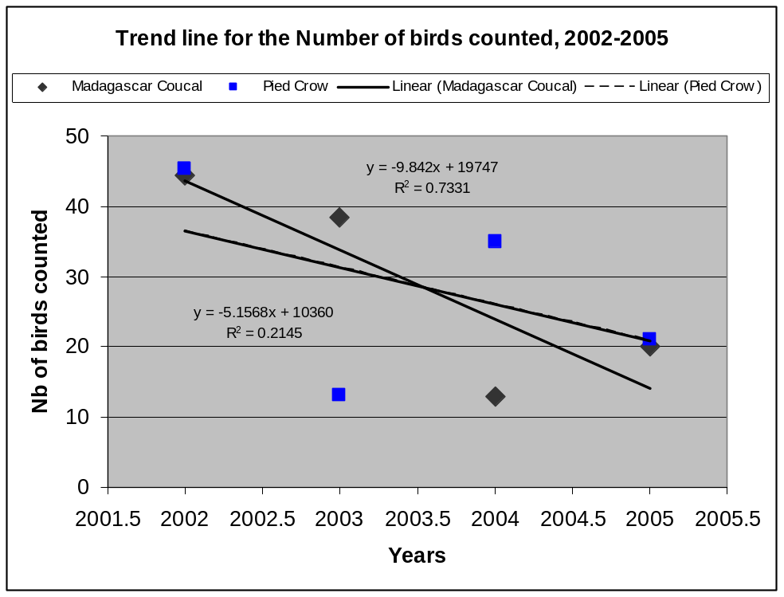
The sacred Ibis counts raised from 34 to 45 but the coefficient (R2= 0.35) is not significant. The Madagascar kestrel is seeing no increase in its counts (R2=0.0195)

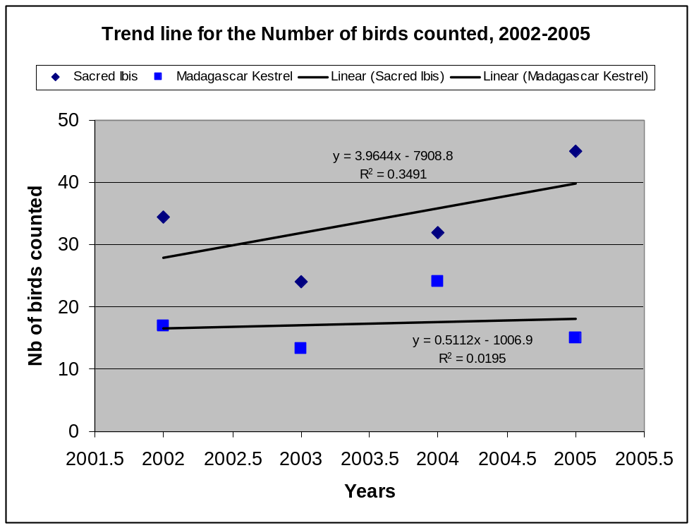

4.2 Rail monitoring !!
Due to the high variance in previous datasets (see 2003 report), Mr Ross Wanless suggested that the rail transects are conducted quarterly rather than monthly. There was a suspicion that the birds were becoming accustomed to the voice recordings and becoming less responsive. From table 3.2, it is evident that there is still high variance in the data. The monitoring program is currently under review (see 2005 monthly reports)

Table 3.2: The number of rails counted per transect in 2004

Month | Malabar | Middle Camp | Polymnie | Gionnet
January | 24 | 27 | 3 | 8
May | 15 | 24 | 3 | 11
September | 9 | 12 | 3 | 6
December | 8 | 17 | 8 | 14

4.3 Wader counts
At the settlement, wader counts were conducted on a monthly basis (Table 3.3). Total number per species and it proportion to the total are given in the table. Counts were conducted on days where the low tide fell over the early morning. All birds present on the beach and exposed reef flat were counted between the settlement and the boat shelter at La Gigi. We also calculated the percentage of each for 2004 (Table 3.4).

In places were the reef flat is very wide, many birds (especially the smaller less distinct ones) were not counted and as a result, these counts should not be treated as total counts. Additional variance created in the data is accounted to observer bias, variable weather conditions and the variable percentage of exposed reef flat during each count.

Table 3.3: Number of seashore birds observed on Picard reef flat, from Settlement beach to la GiGi beach, in 2005, abundance per species.
Species | Jan | Feb | Mar | Apr | May | Jun | Jul | Aug | Sep | Oct | Nov | Dec | Total | % of total
Bar-Tailed godwit |  |  | 13 | 6 | 1 |  | 5 | 2 | 6 |  | 1 | 6 | 40 | 1.5
Black-naped tern | 40 |  | 7 |  | 1 | 2 | 1 |  |  | 3 | 1 |  | 55 | 2.0
Caspian tern |  |  | 1 |  |  |  | 2 | 1 |  |  |  |  | 4 | 0.1
Common sandpiper |  |  |  |  |  |  | 1 |  |  |  | 129 |  | 130 | 4.8
Crab plover | 67 |  | 62 | 187 | 9 | 13 | 27 | 11 | 5 | 8 | 24 | 70 | 483 | 17.7
Curlew sandpiper |  |  |  |  |  | 2 | 1 |  |  |  |  |  | 3 | 0.1
Dimorphic egret | 62 | 13 | 48 | 251 | 186 | 49 | 67 | 27 | 11 | 59 | 41 | 34 | 848 | 31.1
Greater Crested tern | 3 | 1 |  | 6 | 2 |  | 1 |  | 2 | 4 | 1 | 3 | 23 | 0.8
Greater sand plover | 6 |  | 12 | 9 |  | 1 | 1 |  | 4 |  | 3 | 1 | 37 | 1.4
Green-backed heron | 16 | 4 | 8 | 25 | 10 | 16 | 10 | 6 | 7 | 4 | 8 | 6 | 120 | 4.4
Greenshank |  | 5 |  |  | 1 | 3 | 1 | 2 | 2 | 1 | 2 | 2 | 19 | 0.7
Grey heron | 8 | 3 | 7 | 5 | 6 | 8 | 8 | 9 | 7 | 6 | 8 | 9 | 84 | 3.1
Grey plover | 6 | 2 | 3 | 5 | 1 | 1 |  |  | 3 |  | 1 | 3 | 25 | 0.9
Lesser crested tern |  |  |  |  |  | 3 |  | 5 |  |  |  |  | 8 | 0.3
Lesser sandplover | 3 | 1 | 5 | 4 |  |  |  |  | 1 | 3 |  | 1 | 18 | 0.7
Ringed plover | 2 | 1 | 1 | 1 |  |  |  |  |  |  |  |  | 5 | 0.2
Ruddy turnstone | 84 | 91 | 46 | 148 | 16 | 11 | 10 | 9 | 67 | 136 |  | 56 | 674 | 24.7
Sanderling |  | 15 | 5 |  | 1 |  |  |  |  |  | 8 | 40 | 69 | 2.5
Saunders terns |  | 25 |  |  |  |  |  |  |  | 6 |  |  | 31 | 1.1
Whimbrel | 5 | 1 | 12 | 13 | 4 | 2 | 1 | 1 |  | 5 |  | 4 | 48 | 1.8
Pacific golden plover |  |  |  |  |  |  |  |  |  | 5 |  |  | 5 | 0.2
Wood sandpiper |  |  |  |  |  |  |  |  |  | 2 |  |  | 2 | 0.1
Total | 302 | 162 | 230 | 660 | 238 | 111 | 136 | 73 | 115 | 242 | 227 | 235 | 2731 | 100.0

Table 3.4: Number of seashore birds observed on Picard reef flat, from Settlement beach to la GiGi beach, in 2004, abundance per species.
Species | Jan | Feb | Mar | Apr | May | Jun | Jul | Aug | Sep | Oct | Nov | Dec | Total | %
Common sandpiper | 1 |  |  |  |  |  |  |  |  |  |  |  | 1 | 0.1
Eurasian curlew | 1 |  |  |  |  |  |  |  |  |  |  |  | 1 | 0.1
Whimbrel | 2 | 6 | 2 | 2 | 2 | 5 | 1 | 8 | 5 | 2 | 6 | 1 | 42 | 2.1
Ringed plover | 3 |  | 1 |  |  |  |  |  |  |  |  |  | 4 | 0.2
Sanderling | 3 | 4 | 6 |  |  |  |  |  |  |  |  |  | 13 | 0.7
Greater crested tern | 4 | 2 | 5 |  |  | 2 | 1 | 1 |  |  | 3 | 1 | 19 | 1.0
Lesser sandplover | 4 | 8 | 1 |  |  |  | 5 | 2 | 2 |  | 6 | 5 | 33 | 1.7
Grey heron | 5 | 4 | 4 | 7 | 11 | 8 | 4 | 6 | 5 | 8 | 8 | 4 | 74 | 3.8
Lesser crested tern | 6 |  | 7 |  |  |  |  |  |  | 1 |  |  | 14 | 0.7
Green-backed heron | 7 | 1 | 11 | 10 | 7 | 4 | 6 | 9 | 7 | 4 | 4 | 6 | 76 | 3.9
Greater sandplover | 8 | 10 |  | 1 | 2 |  |  |  |  | 8 |  |  | 29 | 1.5
Bar-tailed godwit | 9 | 6 |  |  |  |  | 1 |  |  |  | 10 | 1 | 27 | 1.4
Curlew sandpiper | 9 | 2 |  |  |  |  |  | 4 |  |  |  |  | 15 | 0.8
Grey plover | 12 | 7 | 6 | 1 |  |  | 4 | 2 | 3 | 2 | 8 | 4 | 49 | 2.5
Ruddy turnstone | 44 | 73 | 47 | 7 | 3 | 4 | 25 | 22 | 83 | 98 | 62 | 75 | 543 | 27.8
Crab plover | 78 | 50 | 37 |  | 20 | 7 | 35 | 15 | 3 |  | 72 | 35 | 352 | 18.0
Dimorphic egret | 102 | 152 | 104 | 16 | 81 | 27 | 11 | 40 | 27 | 3 | 60 | 11 | 634 | 32.4
Black-naped tern |  | 8 | 2 |  | 2 | 1 | 1 | 2 | 2 |  | 4 | 1 | 23 | 1.2
Caspian tern |  |  | 1 |  | 1 |  |  | 3 |  |  |  |  | 5 | 0.3
Greenshank |  |  |  |  |  |  |  | 2 |  |  |  |  | 2 | 0.1
 |  |  |  |  |  |  |  |  |  |  |  |  | 1956 | 100.0

The results for the 3 most abundant species are very similar in 2005 and in 2004 (Table 3.5) Indeed it is interesting to note that in 2005 and 2004 not the same four species were found to be the most abundant and in the same decreasing but also their proportion are similar in both years. In both years, first is the Dimorphic egret followed by the Ruddy turnstone, and then the Crab plover.

Table 3.5 The four most abundant species of Waders seen at Settlement in 2005 &2004
2005 |  | 2004
1 | Dimorphic egret (31.1%) | 1 | Dimorphic egret (32.4%)
2 | Ruddy turnstone (24.7%) | 2 | Ruddy turnstone (27.8%)
3 | Crab plover (17.7%) | 3 | Crab plover (18%)
4 | Common sandpiper (4.8%) | 4 | Lesser sandplover (3.8%)

Wader counts along the West Grande Terre were more difficult to organize. Counts were conducted during the monthly walk undertaken by rangers between the Dune Jean-Louis and Dune D’Messe camps. The walk is always conducted in the morning and on those days where the high tide fell over the early morning period, no counts were conducted.

Table 3.4 : Number of seashore birds observed on reef flat between Dune De Messe and Dune Jean Louis, in 2005

Species | Jan | Feb | Mar | Apr | May | Jun | Jul | Aug | Total | % of total
Bar -tailed godwit | 1 | 10 |  |  |  |  |  | 3 | 14 | 0.6
Black-naped tern |  |  |  |  |  |  |  |  | 0 | 0.0
Caspian tern |  |  |  |  | 2 |  | 1 | 4 | 7 | 0.3
Crab plover | 672 | 381 | 50 | 6 | 60 |  |  |  | 1169 | 51.9
Dimorphic egret | 3 | 7 | 5 |  | 6 | 5 | 3 | 4 | 33 | 1.5
Greater crested tern | 1 | 6 |  | 2 |  |  | 3 |  | 12 | 0.5
Greater sandplover | 60 | 3 |  |  |  |  |  |  | 63 | 2.8
Green-backed heron | 5 | 7 | 1 |  |  | 1 | 2 |  | 16 | 0.7
Grey heron | 6 | 5 |  | 4 |  | 2 | 1 | 3 | 21 | 0.9
Grey plover | 2 | 12 | 3 | 2 |  |  | 2 |  | 21 | 0.9
Lesser crested tern |  | 2 |  |  |  |  |  |  | 2 | 0.1
Lesser sandplover | 30 | 340 | 100 | 50 | 50 |  |  |  | 570 | 25.3
Ruddy turnstone | 58 | 172 | 20 | 5 | 26 | 2 | 17 | 24 | 324 | 14.4
Sanderling |  | 1 |  |  |  |  |  |  | 1 | 0.0
Cattle Egret |  |  |  |  |  |  |  | 1 | 1 | 0.0
Total | 838 | 946 | 179 | 69 | 144 | 10 | 29 | 39 | 2254 | 99.9

Table : Wadders count DDM-DJL in 2004.
Species | Feb | Jun | Sep | Dec | Total | % of total
Crab plover | 50 | 20 |  | 200 | 270 | 25.0
Grey plover | 2 |  | 5 |  | 7 | 0.6
Lesser sandplover | 60 |  |  | 44 | 104 | 9.6
Greater sandplover | 120 | 30 | 80 | 35 | 265 | 24.6
Whimbrel | 2 | 1 | 4 | 7 | 14 | 1.3
Curlew sandpiper | 6 |  | 90 |  | 96 | 8.9
Ruddy turnstone |  | 4 | 58 | 162 | 224 | 20.8
Sanderling |  |  | 2 |  | 2 | 0.2
Grey heron |  |  | 7 | 10 | 17 | 1.6
Green-backed heron |  | 2 | 4 |  | 6 | 0.6
Dimorphic egret |  | 1 | 4 | 2 | 7 | 0.6
Greater crested tern |  | 3 | 3 |  | 6 | 0.6
Caspian tern |  | 4 | 2 | 1 | 7 | 0.6
Bar tailed godwit | 4 |  |  |  | 4 | 0.4
Little tern |  |  |  | 50 | 50 | 4.6
 |  |  |  |  | 1079 | 100

It is also interesting to find that at another location, namely on south grande Terre,
2 of the 3 most abundant species are the same however here the Dimorphic egret is not among the 3 most abundant species. Both in 2005 and 2004 it is the crab plover, followed by the Lesser sandplover in 2005 and the Greater sandplover in 2004 and then in both year the Ruddy turnstone that are most abundant.

Table : The four most abundant species of Wader seen at DDM-DJL in 2005 &2004
2005 |  | 2004
1 | Crab plover (51.9%) | 1 | Crab plover (25%)
2 | Lesser sandplover (25.3 %) | 2 | Greater sandplover (24.6%)
3 | Ruddy turnstone (14.4%) | 3 | Ruddy turnstone (20.8%)
4 | Greater sandplover (2.8%) | 4 | Lesser sandplover (9.6%)

3.4 Climate (updated for 2005)

3.4.1: Climatic conditions at Picard Station in 2005:

Manual temperature and rainfall readings have been taken regularly at the station in 2005 (Table 1).

Table 1: Monthly meteorological data from Picard station for 2005
 | Jan | Feb | Mar | Apr | May | Jun | Jul | Aug | Sep | Oct | Nov | Dec
Mean dry bulb, Cº | 28.44 | 28.26 | 27.98 | 28.35 | 27.33 | 25.62 | 24.60 | 24.27 | 24.74 | 26.13 | 27.32 | 27.9
Mean wet bulb,Cº | 27.84 | 27.89 | 27.89 | 27.98 | 27.18 | 25.51 | 24.38 | 24.40 | 24.46 | 25.26 | 26.41 | 26.9
Mean Max ,Cº | 33.60 | 33.55 | 33.84 | 34.02 | 33.97 | 34.00 | 34.00 | 28.26 | 28.56 | 29.37 | 31.31 | 32.3
Mean Min ,Cº | x | x | x | x | x | X | x | x | 23.12 | 24.17 | 24.47 | 25.3
Wind mean | x | x | x | x | x | X | x | x | x | x | x | X
Wind max | x | x | x | x | x | X | x | x | x | x | x | X
Rainfall (mm) | 249.3 | 152.85 | 150.95 | 170.6 | 179.05 | 9.33 | 38.28 | 17.58 | 4.1 | 5 | 25.55 | 77.8

A) Temperature

In 2005, highest temperatures were found at the beginning and the end of the year, with temperatures close to 29 Cº at the beginning and 28 Cº at the end (Figure 1). Generally 2005 is showing the same seasonality pattern as for the period 2000-2004 (Figure 2). Indeed, the first months of the years, temperatures decrease gradually to a minimum close to 24 Cº in July and August, then returning to highest at the end of the year. Some years, the decrease of temperature occurs later, for example in 2005, the first 4 months were at similar temperature. In December 2005 the value remained a bit lower than usual not reaching 28 Cº.

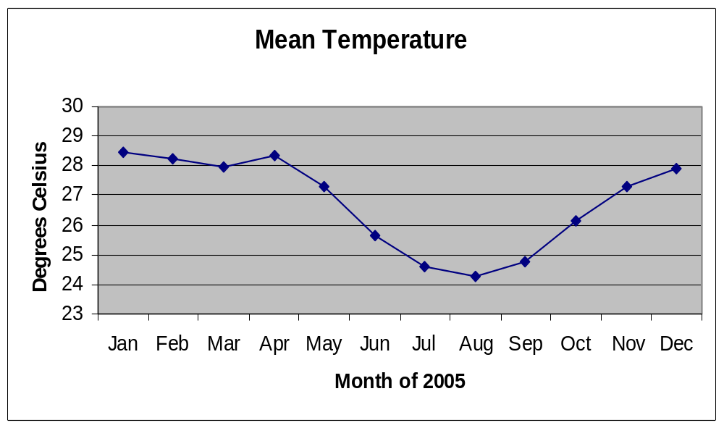
Figure 1: Mean dry bulb temperature at the station in 2005
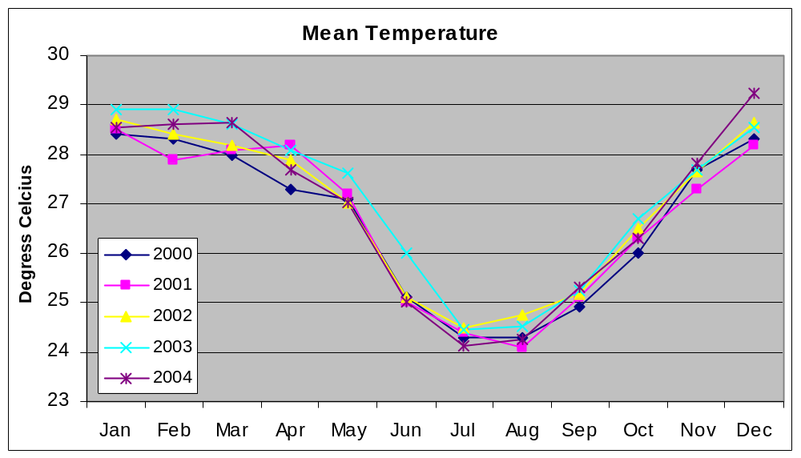
Figure 2: Mean dry bulb temperature between 2000 and 2004

B) Rain fall at Picard station

Rainfall in 2005 (Figure 3) was maximum at the beginning of the year in January, reaching 250 mm. From February to May, in 2005, we observed values close to 150 mm per month. From June a sharp decreased occurred to values situated below 50 mm until November. It is in December that the precipitation increased above the 50 mm reaching 77.8 mm, tripling the amount observed in November.

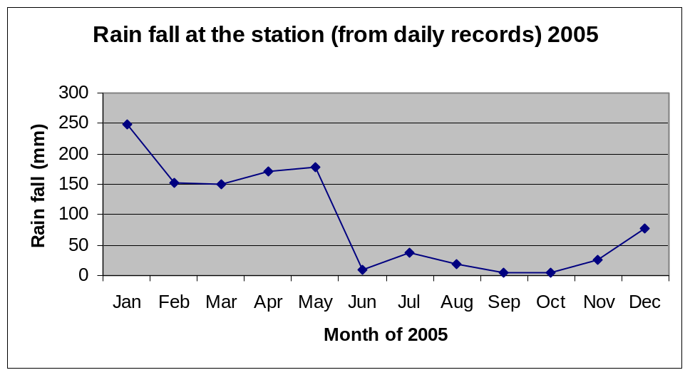
Figure 3: Rainfall at the station for 2005

Generally speaking this is the pattern we observed in most years; however from a year to another, variations can occur. January is not always with the maximum it can often be February and December can reach higher values than in 2005. also show the same rain variation pattern as over the period 2000-2004, have shown typical patterns (Figure 4.2).

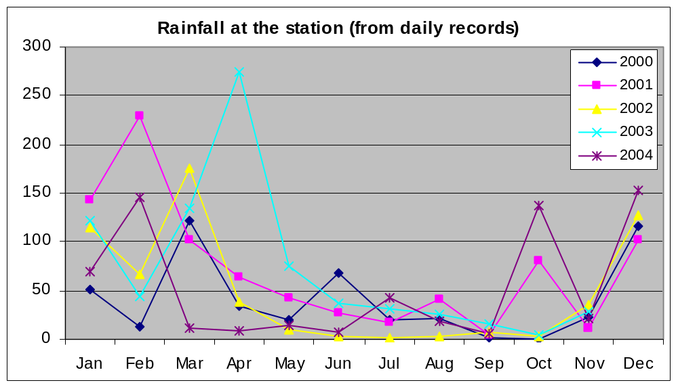

Figure 4: Rainfall at the station between 2000 and 2004

3.4.2: Climatic conditions at outstations on Aldabra:

- Rain fall at outstations

At outstations on Aldabra monthly rain fall is collected (Table 2).

Table 2: Monthly rain fall (mm) per outstation location and total annual rain fall from rain gauges set around Aldabra Island in 2005.
Location | Jan | Feb | Mar | Apr | May | June | July | Aug | Sep | Oct | Nov | Dec | Total*
Cinq Cases Hut | 265 | 320 | 270 | 8 | 184 | 7 | 50 | 3 | 14 | 2 | 7 | 5 | 1278
Cinq Cases Groves | 236 | 330 | 185 | 10 | 195 | 10 | 43 | 5 | 20 | 5 | 10 | 10 | 1221
Dune Jean Louis | 245 | 280 | 155 | 50 | 118 | 31 | 68 | 8 | 14 | 10 | 0 | 40 | 1190
Dune D'Messe | 225 | 295 | 210 | 67 | 180 | 28 | 70 | 10 | 9 | 5 | 0.5 | 75 | 1174.5
Anse Mais | 310 | 90 | 35 | 145 | 292 | 48 | 37 | 25 | 12 | 4 | 10 | 60 | 1135
Anse Var | 112 | 395 | 104 | 60 | 119 | 35 | 20 | 0 | 10 | 0 | 2 | 1 | 1068
Bassin Lebine | 250 | 274 | 170 | 95 | 202 | 51 | 33 | 7 | 13 | 5 | 30 | 60 | 1059
Gionnet | 333 | 280 | 45 | 360 | 67 | 43 | 60 | 18 | 16* | 14 | 5 | 53 | 1046
Polymnie | 140 | 270 | 192 | 226 | 63 | 30 | 42 | 18 | 14* | 10 | 10 | 45 | 1021
Anse Malabar | 450 | 120 | 95 | 155 | 175 | 85 | 31 | 38 | 27 | 20 | 22.5* | 25 | 1019
Middle Camp | 355 | 127 | 110 | 85 | 160 | 45 | 30 | 20 | 17 | 12 | 10 | 50 | 987.5
Ile Esprit | 285 | 100 | 190 | 71 | 257 | 20 | 25 | 5 | 5 | 4 | 0 | 25.5 | 858
Average all locations | 267 | 240 | 147 | 111 | 168 | 36 | 42 | 13 | 14 | 8 | 8 | 37 | 1088.1
* Total annual precipitation per location

The total rain fall, for all outstations combined, is following the same general seasonal pattern as the one observed at Picard station. Maximum is situated in January with low values observed from June to November (Figure 5).

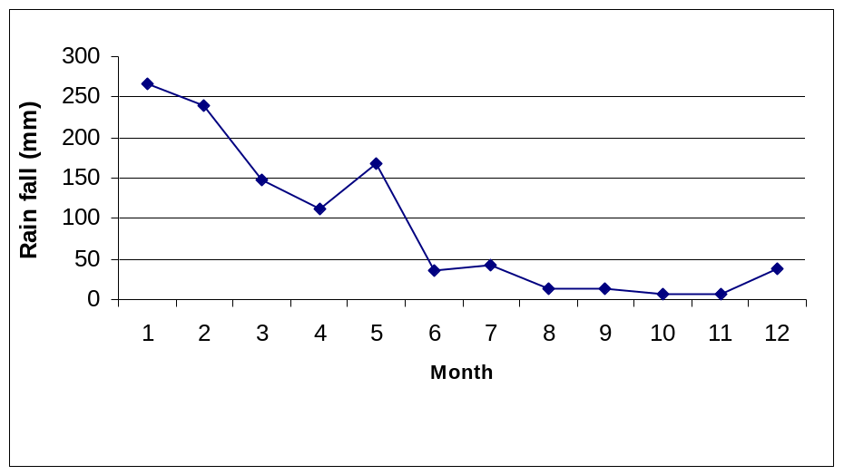
Figure 5: Monthly average rain fall on Aldabra in 2005, all outstations combined.

Total annual precipitation per outstation

In 2005, the outstation with the highest precipitation was Gionnet with 1200 mm. The lowest was Anse var with a value close to 800 mm. In 2005 the rain fall was significantly higher than the average yearly value obtained over the period 1999-2004 for which the maximum value is close to 900 mm and the minimum close to 550 mm (Figure 7).

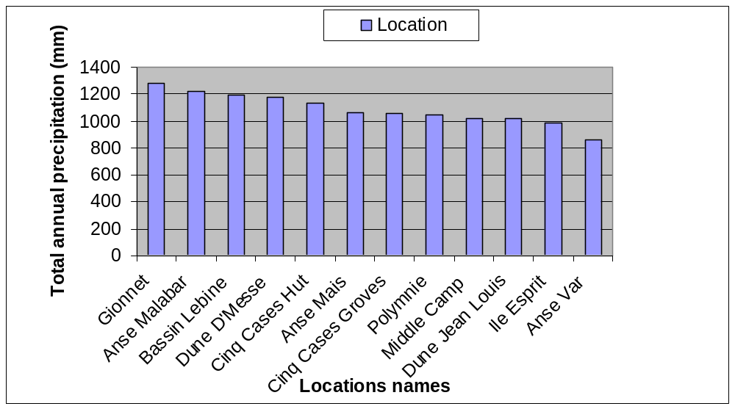
Figure 6: Total annual rain fall at the various outstations on Aldabra in 2005.

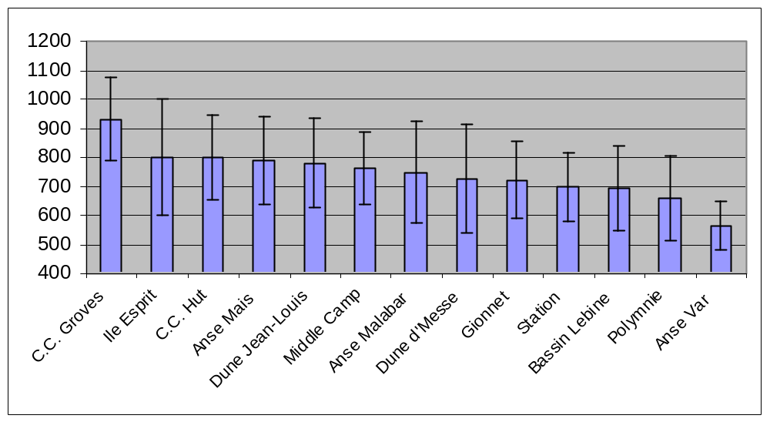

Figure 7: Mean precipitation at the various outstations (1999-2004)
This higher precipitation in 2005 can also be observed from the higher total precipitation value of 1088.1 mm obtained compared with the values of the years 1999-2004. Indeed each other year had values below 1000 mm ( Figure 8).

Figure 8 Mean annual precipitation at Aldabra (1999-2004)

Observations made on Precipitation and wind direction (monsoons) in 2005.

In 2005, the first significant rains came in November (research officer reports) while the wind was still blowing from the South east. Only in December some days the wind changed direction, coming clearly form the North West indicating the beginning of the North-west monsoon season. However sometime even the North-west monsoon season, the wind can still blow from the South-east bringing rain with it.

References:

Mortimer, J.A ,1997. Turtle monitoring at Aldabra

Mortimer, J.A., T. Jupiter, J. Collie, R. Chapman, A. Liljevik, B. Betsy, R. Pimm, J. Stevenson, V. Laboudallon, M. Assary, D. Augeri & S. Pierce. in press. Trends in the Green Turtle (Chelonia mydas) nesting population at Aldabra atoll, Seychelles (WIO) and their implications for the region.. Proceedings of 23rd Annual Symposium on Sea Turtle Biology and Conservation. NOAA Tech Mem.

Bourn, D., Goodridge, S. , 2004. Guide for the Aldabran giant tortoise population monitoring database

Bourn. D., Gibson., Augeri. D., Wilson. C., Church. J., Hay. S., 1999. The rise and fall of the Aldabran giant tortoise population. Proc. R. Soc. Lond. B 266, 1091-1100

Gibson. C. and Hamilton. J. ,1983. Feeding ecology and seasonal movements of giant tortoises on Aldabra atoll. Oecologia 56: 84-92

Bourn. D., Coe. M., 1976. The size, structure and distribution of the giant tortoise population of Aldabra. Phil. Trans. R. Soc. Lond. Vol. 282 B988, 139-175.

